
LEVEL 2 MATERIALS FOR REVIEW S.P.I.R.E. LESSONS
Level 2 Letters; Cut –leave white
Level 2 Letters; Cut -Color Green
Level 2 Letters; Cut -Color Yellow
Level 2 Phonogram Cards; Cut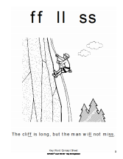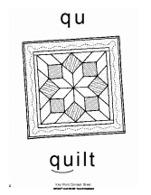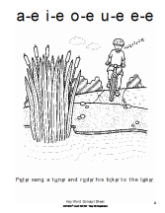
Name: Date:
. . . . . . . .

.
.
.
.
.
.
.
.
^{Classification Dictation Paper} 67
S.P. I.R.E.® Level 1 © SSI • May Be Duplicated
Name: Date:
Sentences
.
.
.
.
.
.
.
.
.
.
₆₅ Full Lesson Dictation Paper
S.P. I.R.E.® Level 1 © SSI • May Be Duplicated
Name Age Grade Teacher Reader Concept Page 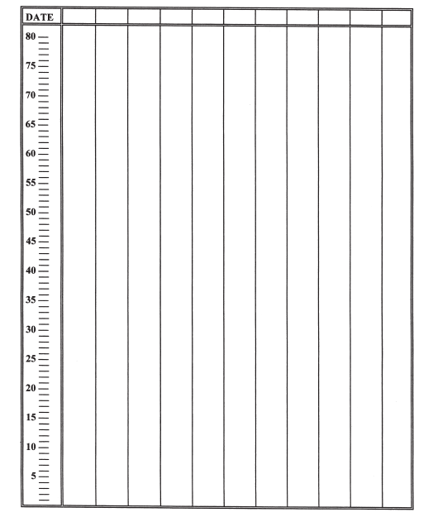
₈₉ Concept Mastery Fluency Drills Progress Report S.P. I.R.E.® Level 3 © SSI • May Be Duplicated
S.P. I.R.E.® Level 3 © SSI • May Be Duplicated

