As the Wife on Mehmed.


Handan was extremely beautiful and was presented to Mehmed. When Mehmed ascended the throne after his father's death in 1595, Handan came to Istanbul with him.

Ahmed's accession
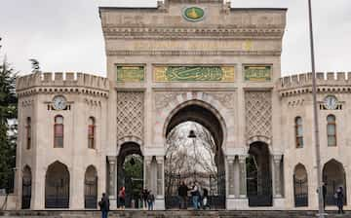
When Ahmed ascended the throne following Mehmed III's death on 22 December 1603, Handan became Valide Sultan (mother of the Sultan). As the mother of the new Sultan, she received 1,000 aspers a day. On Friday 9 January, the former Valide Sultan, Safiye Sultan, along with Şehzade Mustafa (future Mustafa I), were sent to live in the old Palace located at the Beyazıt Square.

As regent
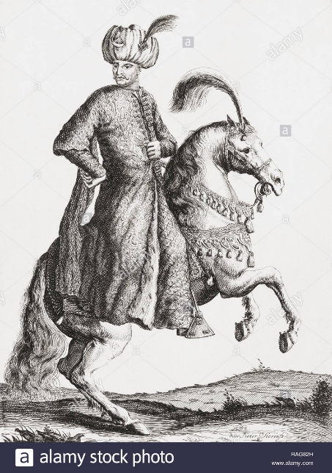
As a co-regent, she immediately began building up her network of followers, and was actively involved in the running of sovereign and royal affairs together with Ahmed's tutor Mustafa.
Ahmed several times announced his eagerness to go to war. It seems that Handan Sultan and Mustafa Efendi advised him to behave in this manner in order to give the public the impression that he was capable of ruling the state. He also began to spend a great deal of time outside the palace, notably hunting, regardless of the weather. Handan Sultan quickly realized that her son could easily put himself in danger and thus needed to be closely watched.
She convinced Ahmed to appoint Yavuz Ali Pasha as head of government, and maintained a close relationship with him, especially during the first critical months of Ahmed's reign. This enabled her to have influence over her son.
Handan Sultan also acted as an intermediary between her son and other government officials. Any vizier who wanted to communicate with Ahmed had to submit his petition first to her. The contemporary historian Ibrahim Peçevi questioned her wisdom, but legitimized her authority over her son by an old and popular saying "a mother's right is God's right"
But her inexperience served her well, she became beloved because she was apolitical. She was known to be kind, wise, and merciful, and overtime despite her political naivete, she ultimately helped her son run his empire successfully. And she loved entertaining her own people at her son’s court.
Sadly, she died at Topkapi palace when she was only 30-31 years old after a long illness.

