##
The diagram shows a temperature sensing circuit used to control a heating system in a house.
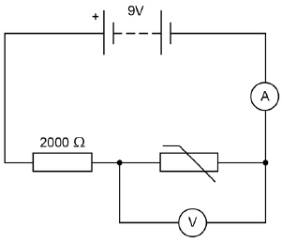

(a) What quantity does the ammeter measure?
___________________________________________________________________
(1)

(b) The current in the circuit is 3.5 mA when the potential difference across the thermistor is 4.2 V
Calculate the resistance of the thermistor.
___________________________________________________________________
___________________________________________________________________
___________________________________________________________________
Resistance = ____________________ Ω
(3)

(c) Calculate the charge that flows through the thermistor in 5 minutes when the current is 3.5 mA.
___________________________________________________________________
___________________________________________________________________
___________________________________________________________________
Charge = ____________________ C
(3)

(d) Explain why the potential difference across the thermistor changes as the temperature in the house decreases.
___________________________________________________________________
___________________________________________________________________
___________________________________________________________________
___________________________________________________________________
(2)

(e) The circuit shown in the diagram can be modified to turn lights on and off by replacing the thermistor with a Light Dependent Resistor (LDR).
Draw the circuit symbol for an LDR in the space below.
(1)
(Total 10 marks)

Q2.Figure 1 shows a Van de Graaff generator that is used to investigate static electricity.
Before it is switched on, the metal dome has no net charge.
After it is switched on, the metal dome becomes positively charged.
Figure 1
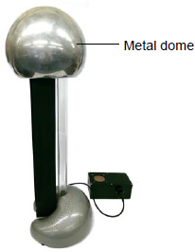
© Michael Priest

(a) Explain how an uncharged object may become positively charged.
___________________________________________________________________
___________________________________________________________________
___________________________________________________________________
___________________________________________________________________
___________________________________________________________________
___________________________________________________________________
(3)

(b) Figure 2 shows a plan view of the positively charged metal dome of a Van de Graaff generator.
Draw the electric field pattern around the metal dome when it is isolated from its surroundings.
Use arrows to show the direction of the electric field.
Figure 2
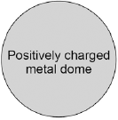
(2)

(c) Another positively charged object is placed in the electric field.
Look at Figure 3.
Figure 3
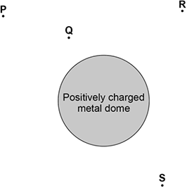
In which position would the object experience the greatest force?

Tick one box.
P | 
Q
R
S

(1)
(Total 6 marks)
##
The image shows a battery-powered drone.
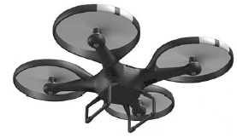

(a) The battery in the drone can store 97.5 kJ of energy.
When the drone is hovering, the power output of the battery is 65.0 W
Calculate the time for which the drone can hover.
___________________________________________________________________
___________________________________________________________________
___________________________________________________________________
___________________________________________________________________
___________________________________________________________________
___________________________________________________________________
Time = ____________________ seconds
(3)

(b) The battery powers 4 motors in the drone.
Each motor has a resistance of 1.60 Ω when the power input to each motor is 19.6 W
The 4 motors are connected in parallel with the battery.
Calculate the current through the battery.
___________________________________________________________________
___________________________________________________________________
___________________________________________________________________
___________________________________________________________________
___________________________________________________________________
___________________________________________________________________
___________________________________________________________________
Current = ____________________ A
(4)
(Total 7 marks)

Q4.(a) A student set up the circuit shown in the diagram. The student uses the circuit to obtain the data needed to plot a current - potential difference graph for a diode.
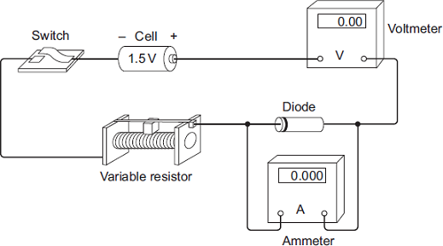
(i) Draw, in the boxes, the circuit symbol for a diode and the circuit symbol for a variable resistor.

Diode |  | Variable resistor

(2)

(ii) The student made two mistakes when setting up the circuit.
What two mistakes did the student make?
1. ____________________________________________________________
______________________________________________________________
2. ____________________________________________________________
______________________________________________________________
(2)

(b) After correcting the circuit, the student obtained a set of data and plotted the graph below.
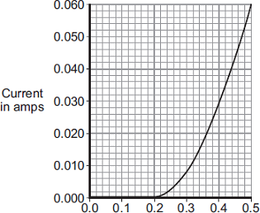
Potential difference in volts
(i) At what potential difference did the diode start to conduct an electric current?
___________________________________ V
(1)

(ii) Use data from the graph to calculate the resistance of the diode when the potential difference across the diode is 0.3 V.
______________________________________________________________
______________________________________________________________
______________________________________________________________
Resistance = _____________ ohms
(3)

(c) The diagram shows the trace produced by an alternating current (a.c.) supply on an oscilloscope.
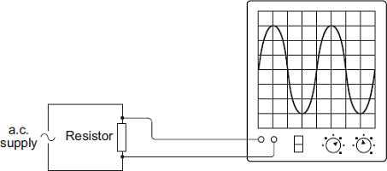
Each horizontal division on the oscilloscope screen represents a time of 0.01s.
(i) Calculate the frequency of the a.c. supply.
______________________________________________________________
______________________________________________________________
______________________________________________________________
Frequency = _______________________ hertz
(2)

(ii) A diode is now connected in series with the a.c. power supply.
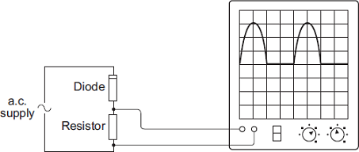
Why does the diode cause the trace on the oscilloscope screen to change?
______________________________________________________________
______________________________________________________________
______________________________________________________________
______________________________________________________________
(2)
(Total 12 marks)

##
(a) current
1

(b) 4.2 = 3.5 × 10^{–3} × R
1
R = 4.2 / 3.5 × 10^{–3}
1
R = 1200 (Ω)
an answer of 1200 (Ω) scores 3 marks
an answer of 1.2 scores 2 marks
1

(c) conversion from minutes to seconds (300 s)
1
Q = 0.0035 × (5 × 60)
1
Q = 1.05 C
an answer of 1.05 (C) scores 3 marks
an answer of 17.5 scores 1 mark
an answer of 1050 or 0.0175 scores 2 marks
1

(d) (potential difference) increases
1
(because thermistor) resistance increases
2nd mark dependent on scoring 1st mark
1

(e) 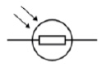
1
[10]

M2.(a) negatively charged
1

electrons are transferred
1

from the (neutral) object
1

(b) minimum of four lines drawn perpendicular to surface of sphere
judge by eye
1

minimum of one arrow shown pointing away from sphere
do not accept any arrow pointing inwards.
1

(c) Q
1
[6]
##
(a) 97 500 = 65.0 × t
1
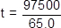
1
t = 1500 (s)
an answer of 1500 (s) scores 3 marks
an answer of 1.5 scores 2 marks
1

(b) 19.6 = I² × 1.60
1
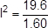
1
I = 3.5 (A)
allow 1 mark for a correct value for I correctly multiplied by 4
1
current through battery = 14 (A)
an answer of 14 (A) scores 4 marks
1
[7]

M4.(a) (i) symbol for a diode 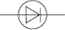
accept 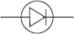
1

symbol for a variable resistor 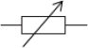
1

(ii) voltmeter is in series or voltmeter is not in parallel
1

ammeter is in parallel or ammeter is not in series
accept an answer in terms of how the circuit should be corrected
voltmeter and ammeter are wrong way around is insufficient
1

(b) (i) 0.2 (V)
accept any value between 0.20 and 0.21 inclusive
1

(ii) 37.5
allow 1 mark for I = 0.008
or
allow 2 marks for correct substitution, ie 0.3 = 0.008 × R
or
allow 1 mark for a correct substitution using I = 0.8 or I = 0.08
or I = 0.009
or
allow 2 marks for answers of 0.375 or 3.75 or 33(.3)
3

(c) (i) 25
allow 1 mark for obtaining period = 0.04(s)
2

(ii) diode has large resistance in reverse / one direction
1

so stops current flow in that / one direction
allow diodes only let current flow one way / direction
allow 1 mark for the diode has half-rectified the (a.c. power) supply
1
[12]

