Ventilation
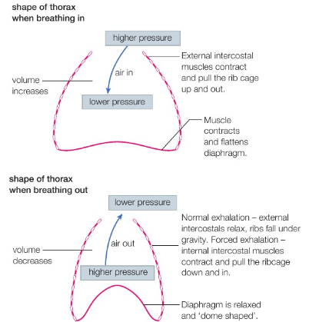
What is ventilation?

Question
What is forced exhalation? How does it occur? Who might want to use forced exhalation?

Once inhalation has occurred, exhalation can begin. This is a passive process.
External intercostal muscles contract which moves the rib cage up and out.
External intercostal muscles relax so the rib cage moves down and in.
Volume of chest cavity decreases, pressure increases and air is forced out of the lungs.
Inhalation is active (uses energy).Diaphragm contracts and flattens.
Diaphragm relaxes and becomes ‘dome shaped’.
The volume of the chest cavity increases, pressure decreases and air is forced into the lungs.

Once inhalation has occurred, exhalation can begin. This is a passive process.
External intercostal muscles contract which moves the rib cage up and out.
External intercostal muscles relax so the rib cage moves down and in.
Volume of chest cavity decreases, pressure increases and air is forced out of the lungs.
Inhalation is active (uses energy).Diaphragm contracts and flattens.
Diaphragm relaxes and becomes ‘dome shaped’.
The volume of the chest cavity increases, pressure decreases and air is forced into the lungs.

