The Cold War 1941-1991
20% of your overall mark
Sat with Early Elizabethan England on paper 2
Friday 8th June 2018 PM 1 hour 45 minutes

You will ONLY be tested your knowledge e.g. no sources or interpretations
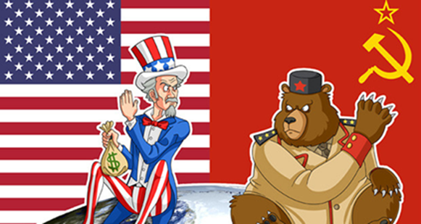

Name:
Teacher:
What does the specification require me to know?
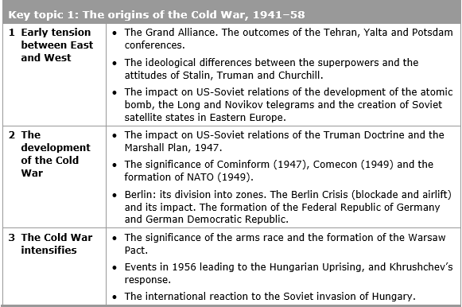
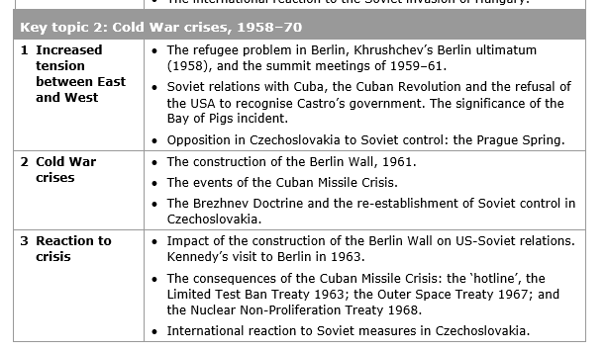
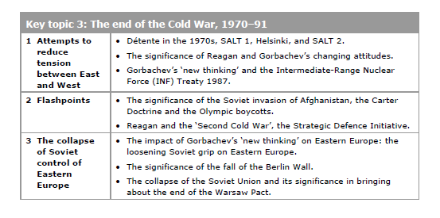
How do I revise?
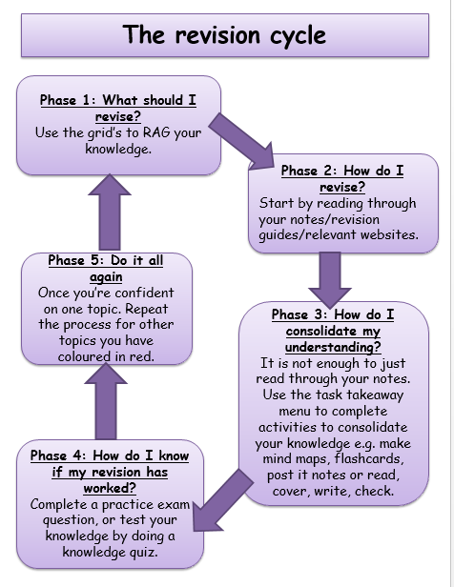

How could I revise?
‘Brain dumps’
Take a big piece of paper or a whiteboard, and write down everything you can remember about the topic you are revising e.g. Hungarian Uprising 1956
You could write down:
- Dates
- Names of individuals
- Key events
- Important place names
- Consequences
- Any other important information
Once you are happy that you cannot remember any more, use different colours to highlight or underline the words in groups. E.G. If revising Cuban Missile Crisis you may choose to underline all the mentions that relates to the causes in red, and to the effects in blue
Learning walks
Make use of your space! Write down key facts and place them around your home, where you will see the every day. Make an effort to read the facts whenever you walk past them.
Distilling
Memory studies show that we retain information better if we visit it regularly. This means that revising the information once is not necessarily going to help it stay in your brain. Going back over the facts at intervals of less than a week leads to the highest retention of facts.
To make this process streamlined, try distilling your notes. Start by reading over the notes you’ve completed in class, two days later read over them again, and then write down anything you did not remember. If you repeat this process enough you will end up with hardly any facts left to write down, because they will be stored in your brain
Using your own downtime
There are always little pockets of time through the day which are not good for anything – bus journeys, queues, ad breaks in TV programmes, waiting for the shower to heat up etc. If you add all of these minutes up it would amount to quite a lot of time, which could be put to good use for revision. You could photograph your revision notes, or record yourself saying your notes out loud.
Que cards
Summarise key events onto que cards/A3 paper, and keep practicing. Practice past exam questions and quick quizzes.

Who are the key leaders?
USSR | USA
Stalin 1924-1953 | Roosevelt 1933-1945  Truman 1945-1953
Khrushchev 1955-1964 | Eisenhower 1953-1961  Kennedy 1961-1963
Brezhnev 1964-1982 | Johnson 1963-1969  Nixon 1969-1974  Ford 1974-1977  Carter 1977-1981
Gorbachev 1985-1991 | Reagan 1981-1989  Bush 1988-1993

It is important to know who the different leaders were at each point

Key topic 1: The origins of the Cold War, 1941 – 1958
1.1 Early tension between East and West
The Cold War was not like previous World Wars. America and the USSR never declared war on each other, nor did they face each other in battle. They both took part in proxy wars – that is they helped their allies to fight the other Superpower or their allies but did not become directly involved in the conflict themselves. This is because both sides knew that a Third World War, a Nuclear War would be unwinnable.
The Cold War was a race to become the biggest and strongest superpower, to prove once and for all that their ideology was the best. It did however have many characteristics of an actual war: arms race, alliances and propaganda.

What were the different ideologies?
. CAPITALISM VERSUS COMMUNISM….
Ideology | Capitalism – Capitalist - WEST | Communism – Communist - EAST
Focus | Individual Rights | Rights of the working class
Values | Individual Freedom | Equality
Economy | Free Trade | Government Planned
Politics | Democratic Elections | Dictator and Communist Party controls the government

Both sides feared the other was out to destroy it. The Soviets believed the west was out to destroy communism. The West believed Soviets wanted to spread communism around the globe.
Stalin’s Suspicion of the West
The USSR had been attacked previously, Germany had invaded Russia in 1914, in 1918, Allied forces had invaded Russia during the Civil War. Hitler had invaded in 1941. Stalin believed it was essential to have friendly countries on his border to prevent this happening again.

Stalin did not trust the West. The West had been appeased Hitler in the 1930s - Stalin believed they had wanted Hitler to destroy communism. The West was also slow to open a Second Front during the Second World War to help the Russians fight Hitler.

What was The Grand Alliance?
The Grand Alliance was established by USSR, USA and Britain from 1941 to defeat the axis powers led by Germany, Japan and Italy. Following the end of the Second World War the Big 3 hoped to continue their friendship but as it became clearer that the Germany was defeated the Big 3 began to have conflicting aims and objectives.
The conferences
Tehran, November 1943
AIM:
Plan a strategy to win the war
AREAS OF AGREEMENT:
- USA and Britain would open a ‘second front’ easing pressure on the Eastern Front (Soviets = heavy losses)
- Stalin would declare war against Japan and supply Soviet troops to help the USA win the war against Japan BUT… only when the war in Europe was over
- Discussed what would happen to Germany after the war – no formal agreement BUT it was agreed that Germany should remain week
- An international body should be set up to settle disputes
IMPACT?
- Before the conference, Stalin felt that the USA and Britain were deliberately trying to delay the opening of a ‘second front’ so he was pleased with the agreement that there would be a ‘second front’
- Agreement between Stalin and Roosevelt over where the ‘second front’ should open
- Generally good relations between Roosevelt and Stalin

Yalta, February 1945
AIM:
Discuss winning the war and the government of post-war Europe
‘Second front’ had been launched in France
Soviets had defeated Germany in the Soviet Union and they had control of most of Central and Eastern Europe
AREAS OF AGREEMENT:
- Germany would be split into four zone – each controlled by a different power (USA, Britain, France and the Soviet Union)
- Germany would pay $20 billion in reparations
- Nazi Party banned and war criminals prosecuted
- United Nations would be set up
- Stalin agreed to join the war against Japan
- Stalin agreed that future governments of countries in Easter Europe would be decided in free elections

AREAS OF DISAGREEMENT:
- Stalin wanted all 16 Soviet republics to be given individual membership to the United Nations. Britain and France disagreed. Russia, the Ukraine and Belarus were admitted
- Issues over Poland – it was agreed that the borders of Poland should be returned to their position in 1921 (giving the USSR significant gains), and that there would be free elections. BUT… Stalin wanted to ensure a pro-Communist government came to power, whereas the British wanted the London Poles to be elected
Potsdam Conference, July-August 1945
IMPORTANT CHANGES SINCE YALTA:
Harry Truman had replaced Roosevelt. Truman was determined to take a get tough approach with Stalin and was very anti-Communist
Churchill had lost the election and was replaced by Clement Atlee. There were issues in Britain that Atlee needed to deal with and therefore he was rushing the discussions to get back to Britain.
Germany had surrendered in May 1945 – no common enemy
The USA had developed the atomic bomb
AREAS OF AGREEMENT:
- Germany would be divided into 4 zones
- Berlin would also be divided into 4 zones (even though Berlin was part of the Soviet zone)
- Each administering country should take reparations from its own zone
- Soviet Union had the poorest zone (which they hated). It was agreed that the Soviets could take a quarter of the industrial equipment from the other zones
AREAS OF DISAGREEMENT:
- Disagreements over the governments of Eastern Europe – how governments should be formed and who should rule them. Stalin wanted security for the USSR so he wanted there to be pro-communist governments
- How much reparations Germany should pay: the USSR wanted Germany to pay a significant amount, whereas the USA and Britain felt this would not be fair to Germany’s overall recovery.
The Atomic Bomb
On 16th August, during the Potsdam Conference, the USA successfully tested their first A Bomb. Truman informed Stalin about it, but was not willing to share the technology. This made Stalin even more suspicious of the West and encouraged him to begin an arms race to make the USSR’s weapons equal in force to those of the USA.
The Arms Race was pushed along by fear.

Until 1949 the USSR could not risk a war against USA. When the USSR exploded its own nuclear weapon in 1949 tension began to increase. The USA began to develop the H bomb. In 1952 the USSR exploded its own H-bomb. The USA began to build bomber aircraft, to deliver the H-bomb, in the mistaken belief that the USSR had more bomber aircraft than the USA did.

The Secret Telegrams

Truman and Stalin both feared the breakdown of the grand alliance and the subsequent threat of a new war. Both had secret reports from their embassies for information on the other leader and their plans. The reports were sent as telegrams.

The Long Telegram

Truman received a worrying telegram from Kennan – he was America’s ambassador in Moscow.
Kennan reported that:
•Stalin had given a speech calling for destruction of capitalism
•America could have no peace with Russia while it opposed capitalism
•Russia was building military power.
•The USA should seek to contain communism.

The Novikov telegram
Stalin received a worrying telegram from Novikov – he was the USSR’s ambassador in Washington.
Novikov reported that:
•America desired to dominate the world.
•Following Roosevelt’s death, the American government was no longer interested in co-operation with the USSR.
•The American public were being prepared for war with the USSR.
Following both telegrams, both countries believed that there was a great possibility of war. The USSR believed that war was inevitable whereas the Americans had labelled Stalin as 'the new Hitler'. By the end of 1946, the Grand Alliance was all but over. America believed the USSR were preparing for world domination and vice versa. This was the unofficial start of the Cold War.
Iron Curtain speech, 1946
In March 1946, Churchill made a speech in Fulton (USA) which stated that an ‘iron curtain had descended across the continent of Europe’ – the Iron Curtain being an imaginary line that divided the communist East from the capitalist West.

The creation of Satellite States
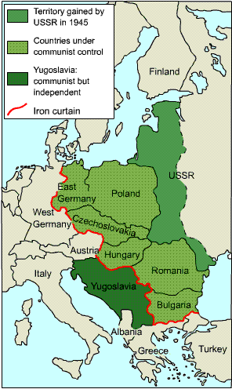
The USSR responded to its nuclear inferiority by strengthening its control over Eastern Europe.
Rigged elections, violence, intimidation and other methods were used to gain control over Eastern European states including Bulgaria, Hungary, Poland and Romania.
By 1947 all eastern European states apart from Czechoslovakia had communist governments (Czechoslovakia came under communist government in 1948). No free elections had been held as agreed to at Yalta.
The USSR justified its actions;
- It had created a buffer zone against the West.
- It was afraid of the USA’s atomic power
- It was afraid of an attack by the West in the near future.
- It had created a ‘sphere of influence’ as agreed at Yalta.

The USA claimed;
- The USSR had seized control of Eastern Europe and rejected free elections as agreed at Yalta.
- The USA feared that the USSR was determined to extend its influence into Western Europe (and then the rest of the world!!)

The USSR claimed that their measures were defensive, but the USA claimed they were aggressive and a threat to the west.

1.2: The development of the Cold War:
Containment
The Truman Doctrine
Between 1945 and 1949 the USA sought to contain the spread of communism, first in Europe but later around the globe. The USA believed that the USSR was determined to expand and that the USA should use any means possible to stop that expansion.

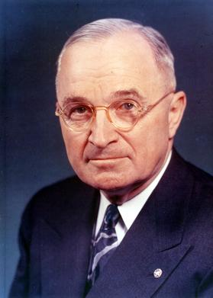
Greece was the first country to benefit from this policy. During WW2 the Greek resistance to the German occupation had been divided into supporters of the monarchy and the communists. At the end of the war British troops had helped to restore the monarchy but were now under attack from the communists. By 1947, Britain could no longer afford to continue to keep troops in Greece and so they asked for help from the USA. The USA provided money to keep the British troops in Greece
“I believe that it must be the policy of the United States to support free peoples who are resisting attempted subjugation by armed minorities or by outside pressures.”

In 1947 President Truman outlined the USA’s response in what became known as the Truman Doctrine.
This policy was designed to stop the spread of communism - it was called containment
Policy was driven by a belief in the ‘Domino Theory' – the USA should prevent one country from falling to communism to stop others from following suit.
It was believed that it was America's duty to protect democracies from the threat of communism. It would do this by providing money, aid, advisors or even weapons to any country threatened by communism.
USA showed this policy in action when it installed ballistic missiles in Turkey - the USSR had no such missiles and therefore saw this action as hostile.
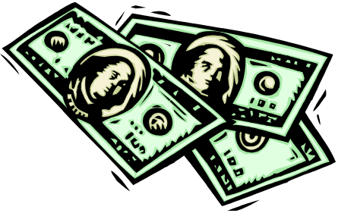
The Marshall Plan
The Marshall Plan is an economic extension of the Truman Doctrine
Europe’s economy had been shattered by WW2. Europe had to tackle the devastation caused by the war, the impact of the bombing, the loss of lives, the destruction of industry, refugees and a mountain of debt. Europe owed the USA $11.5 billion.
US Secretary of State George Marshall believed that countries suffering from poverty and unemployment were more likely to turn to communism. The aim of the Marshall Plan was therefore to rebuild the shattered European economy so that it could contain the spread of communism. A fund of $15 billion was made available to any nation who applied for it.
The Marshall Plan aimed to:
- Raise living standards in Western Europe to reduce the appeal of communism.
- To rebuild Germany
- To weaken Soviet control over Eastern Europe
- To help the US economy by increasing US exports to Europe. They did not want a repeat of the 1920s.

The US government was initially insure about providing so much money to Europe, however, events in Czechoslovakia soon changed their minds.
Consequences of the Truman Doctrine
- Greek government was able to defeat the communists
- Rivalry between the USA and the Soviet Union increased. Truman had publicly stated that the world was divided with two different ways to live – the free and the unfree.
- The USA became committed to a policy of containment and far more involved in European affairs
- The USA decided to provide economic aid to Europe (Marshall Plan) although this was motivated by US self-interest
- In 1947, Stalin retaliated by setting up Cominform – a clear reaction and a clear development in the intensification of relations.

Consequences of the Marshall Plan
- By 1953, the USA had provided $17 billion to help European countries rebuild their economies and raise their standard of living. US machinery helped European factories to recover from the effects of the Second World War. US advisers helped to rebuild transport systems.
- Europe became more firmly divided between East and West. Stalin was initially involved but withdrew the Soviet Union from discussions because he did not trust the USA and did not want to show how weak the Soviet Union really was economically. He prevented eastern European countries, such as Czechoslovakia and Poland from becoming involved.
- Stalin accused the USA of using the Plan for its own selfish interests – to dominate Europe and boost the US economy.

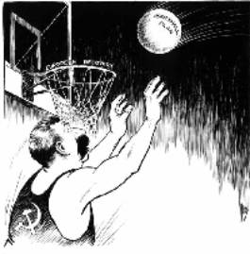
Stalin’s Reaction to the Marshall Plan

Stalin called the Marshall Plan ‘dollar imperialism' and claimed the USA was trying to control industry and trade in Europe. He believed that it sought to undermine communism and to promote the spread of capitalism across the globe. He refused to accept any economic aid and stopped any Eastern bloc country applying for it.

Cominform (1947) and Comecon (1949)
To try to prevent any eastern European countries applying for Marshall Aid, Stalin offered help and support to Eastern Europe by setting up two organisations, Cominform (1947) and Comecon (1949).
Cominform (Communist Information Bureau) was an alliance of European communist parties to help them plan and to work together and spread Stalin’s ideas. It increased the control Stalin had over these countries, and limited their independence. Only Marshal Tito, the communist leader of Yugoslavia, would not accept Stalin’s total leadership and split with Moscow.
Comecon (Council for Mutual Economic Aid) was set up to coordinate the production and trade of the eastern European communist countries. They were expected to trade with each other and not the West. However, it favoured the USSR more than any of its other members.

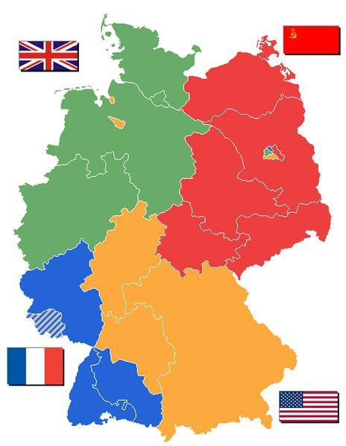
The Berlin Crisis (blockade): 1948-49
Germany, and Berlin, had been divided in 1945 into zones of occupation. This was a source of tension which peaked during the Berlin Crisis of 1948-49.
Causes of the Berlin Crisis/Berlin Blockade:
- Britain, France and the USA had merged their zones of West Germany into one in March 1948
- Britain, France and the USA had then introduced a new currency called the ‘Deutsch mark’ to western Germany, which was intended to help it become economically stronger.
- There was a crisis as capitalism was drawing many people away from the communist east towards greater opportunities and freedoms in the west.
As a result:
- Stalin felt threatened by Germany’s growing strength
- Stalin was angry that the west had not consulted him before making changes in their zones of Germany
- Stalin wanted the ‘cancer’ of West Berlin to be removed from East Germany.

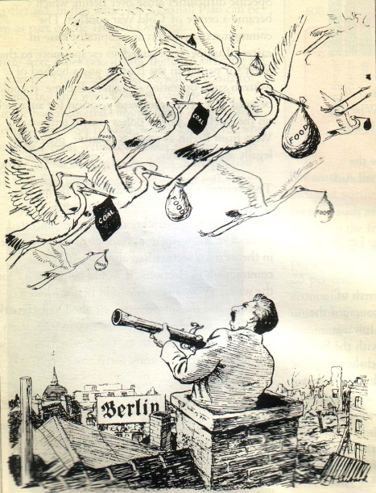
What happened?
In June 1948 Stalin cut off all road, rail and canal links to West Berlin – the Berlin Blockade. The city only had 6 weeks supplies of food and fuel. Stalin aimed to starve the 2 million inhabitants in West Berlin into submission. He believed that Truman would either have to give up West Berlin or go to war.

But the West responded with a massive airlift - food, fuel and supplies were flown into Berlin for 10 months. Stalin dared no shoot down any planes – it would be an act of war. Stalin called off the Blockade in May 1949.

Outcomes/consequences:
- A propaganda victory for the West - Truman had shown he would not allow the policy of containment to fail.
- Stalin was humiliated - the USSR had failed to extend its influence
- The division of Germany into two separate states - in May 1949 the new Federal Republic of Germany (FRG) was set up. In October the eastern zone became the German Democratic Republic (GDR)
- The formation of NATO.
- Deepened hostility between East and West.

What were the consequences of the Berlin crisis?
- Confirmed the divisions of Germany and Berlin: western Allies announced that their former occupation zones (including Berlin) would form together to make the FRG
- Greatly increased East-West tensions: it was a victory for the West; massive humiliation for Stalin
- Led to the setting up of NATO: committed America to the defence of Europe

What was NATO?
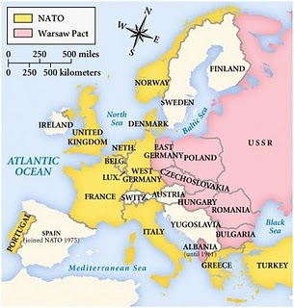
The North Atlantic Treaty Organisation (NATO) was formed in April 1949 by the Western powers. This was during the period of the Berlin Blockade, and was partly in response to Stalin’s aggression. The original twelve members of NATO in 1949 were the United States, the United Kingdom, Canada, France, Denmark, Iceland, Italy, Norway, Portugal, Belgium, Netherlands, and Luxembourg. NATO was a military alliance that committed all members to the defence of all the others.
But NATO was more than a promise of American help in an emergency. The alliance was to be supported by large numbers of troops on the ground. In particular, there were a large number of troops in West Germany. By 1953, 5 divisions of US troops were permanently based there.
Stalin, unsurprisingly, saw NATO as a threat to the USSR and Eastern Europe.

What were the consequences of the setting up of NATO?
- The USA was now fully committed to the defence of Western Europe – instead of isolating herself from European affairs
- Stalin believed it was aimed against the Soviet Union; increasing tensions
- Intensified the arms race between the two sides and the development of weapons of destruction
- The Soviet Union set up the Warsaw Pact within 6 years – a military treaty protecting the USSR and the satellite states
- USA set up its own missile bases in western Europe

What was the Warsaw Pact?
The Warsaw Pact was set up in 1955. The Warsaw Pact was a defensive military alliance of the USSR and its satellite states in Eastern Europe. It was intended as a counter-force to NATO, which was a military alliance of western powers.
The Warsaw Pact, like NATO, relied on collective security – if one nation was attacked, the others would come to its support. The Warsaw Pact helped to make Eastern Europe an effective ‘buffer zone’ for the USSR against the West.

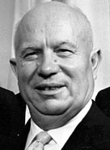
Key Topic 1.3: The Cold War intensifies

The death of Stalin
Stalin died in 1953. After a short struggle for power, in 1955 Khrushchev became the new ruler of the USSR. At first, the western powers hoped that Khrushchev would be the start of a ‘thaw’ in the Cold War.
-Khrushchev met western leaders at ‘summit’ meetings and even travelled to the USA.
-In the ‘Secret Speech’ at the Twentieth Party Congress in 1956, Khrushchev attacked Stalin, saying that Stalin was a murderer and a tyrant. Khrushchev began to ‘de-Stalinize’ Russia - political prisoners were set free and the activities of the secret police were reduced.
-Khrushchev said that he wanted peaceful co-existence with the West. Western leaders hoped this meant the end of the Cold War.
Given hope that Stalin’s era of repression and fear had come to an end, opponents of communism in Eastern Europe began to make demands.

The arms race

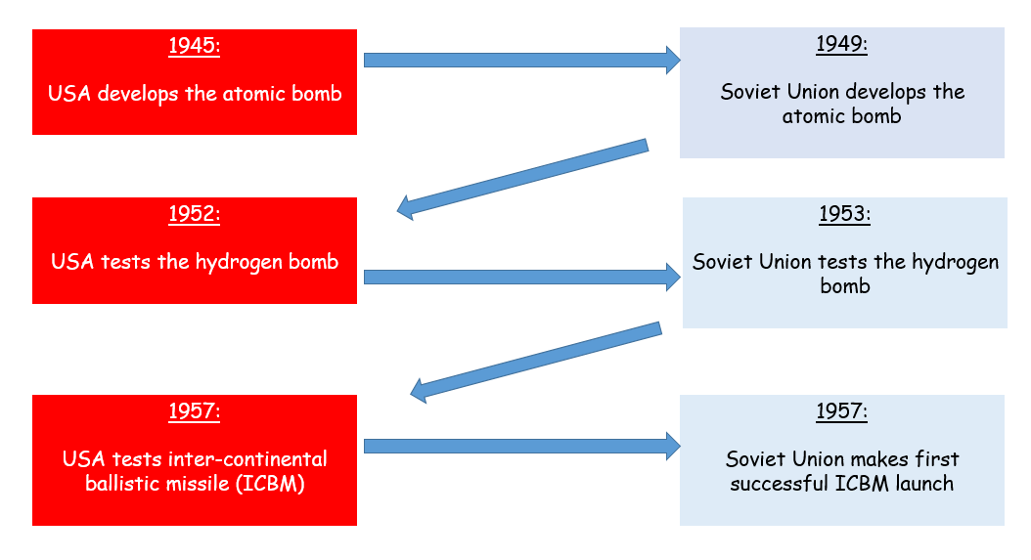

Why was the arms race important for the development of the Cold War?
- Balance of terror – could destroy the world many times over
- Each side felt threatened by the other
- Had to try and stay ahead of the game, be better than the other side
- Each side made more alliances and built more weapons
- Strained relations
- 1957 Sputnik was launched by the USSR; could orbit the earth in 1 ½ hours = military threat
- Increased tension as there was a constant fear of what could happen
There were also two new leaders… Khrushchev and Eisenhower.
Why was there hope that relations would now cool off?
- Change in leadership made people on both sides hopeful that tensions between the Soviet Union and USA could be reduced
- Solution to the Cold War arms race could be found
- 1950 war in Korea in which the USA and Soviet Union supported different sides – July 1953 it had ended
- USA and the Soviet Union spending large sums on their armed force. Reducing spending would be good for their economies.
- July 1955 Geneva summit meeting – agreement on how Austria should be governed
- Geneva failed to reach an agreement over disarmament and the future of Germany BUT the atmosphere of co-operation at the meeting reduced some of the tension
- May 1955 – West Germany joined NATO
- Soviets responded by the formation of the Warsaw Pact = still suspicion existing.

The Hungarian Uprising, October 1956:
- In 1956, the people of Hungary began to protest about their lack of political freedoms and problems created by fuel shortages and poor harvests
- October 1956, riots in Budapest
- Soviet troops restored order
- Khrushchev replaced Rakosi with Imre Nagy – Communist but believed there should still be personal freedoms
- Khrushchev hoped his appointment would end the protests
- Nagi announced a set of proposed reforms – reorganised the Hungarian government, to include members of non-Communist parties
- This ended the one-party state in Hungary
- Authorised the release of political prisoners and persuaded Khrushchev to withdraw Soviet troops from Hungary
Causes of the uprising
- Poverty: Hungarians were poor, yet much of the food and industrial goods they produced was sent to Russia.
- Russian Control: The Hungarians were very patriotic, and they hated Russian control – which included censorship, the vicious secret police and Russian control of what the schools taught. Religious issues: The Hungarians were a religious people, but the Communist Party had banned religion, and put the leader of the Catholic Church in prison.
- Help from the West: Hungarians thought that the United Nations or the new US president, Eisenhower, would help them.
- De-Stalinisation: When the Communist Party tried to de-Stalinise Hungary, things got out of control. The Hungarian leader Rakosi asked for permission to arrest 400 trouble-makers, but Khrushchev would not let him.

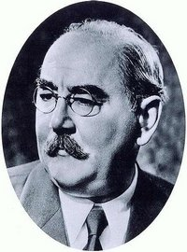
Events of the uprising
- 23 October: Riots of students, workers and soldiers. They smashed up the statue of Stalin, and attacked the Secret Police and Russian soldiers.
- 24 October: Imre Nagy took over as Prime Minister. He asked Khrushchev to take Russian troops out of Hungary.
- 28 October: Khrushchev agreed, and the Russian army pulled out of Budapest.
- 29 October – 3 November: The new Hungarian government introduced democracy, freedom of speech, and freedom of religion (the leader of the Catholic Church was freed from prison). Nagy also announced that Hungary was going to leave the Warsaw Pact.
- 4 November: At dawn, 1000 Russian tanks rolled into Budapest. By 8.10 am they had destroyed the Hungarian army and captured Hungarian Radio – its last words broadcast were ‘Help! Help! Help!’ Hungarian people – even children – fought them with machine guns. Some 4000 Hungarians killed fighting the Russians.
- Khrushchev put in Janos Kadar, a supporter of Russia, as Prime Minister.
- Nagy was executed.

Outcomes/Consequences of the Hungarian Uprising:
- 200,000 Hungarian refugees fled into Austria.
- Russia stayed in control behind the Iron Curtain.
- People in the West were horrified – many British Communists left the Communist Party.
- It was clear to Eastern Europe that the West would not come to their aid to help them overturn communism.
- However, whilst they would not intervene in countries that were within the Soviet sphere of influence, Western leaders became even more determined to ‘contain’ communism.
- Khrushchev’s position became more secure in the Soviet Union. Stronger position in the Warsaw Pact
- Members knew to do as they were told

Check your understanding: Answer these quick fire questions
- Name the two different ideologies of the USA and USSR?
- Which countries were part of the Grand Alliance?
- When was the Yalta Conference? Name one thing that was agreed there.
- What did they disagree about at the Yalta conference?
- When was the Potsdam Conference? What was there?
- What did they disagree about at Potsdam
- What happened on 16th August 1949? What did it lead to?
- Who was George Kennan?
- How did the USSR justify creating Satellite States?
- Which countries became under the control of the USSR?
- What was the Truman Doctrine?
- Which was the first country to benefit from the Truman Doctrine?
- What did George Marshall believe could happen to Europe after WW2?
- How much money did the USA make available for the Marshall Plan?
- How did the USSR respond to the Marshall Plan?
- What is Cominform?
- What is Comecon?
- Identify 2 causes of the Berlin Crisis.
- What happened during the Berlin crisis?
- How did the West respond to the Berlin Crisis?
- When did Stalin die?
- Who became leader after Stalin died?
- Give two examples of methods of de-Stalinisation
- When was the Hungarian Uprising?
- Identify two causes of the Hungarian Uprising.
- What did the new Nagy introduce between 29th October- 3rd November?
- How many tanks entered Budapest on 4th November?
- What happened to Nagy?
- Who replaced Nagy as leader of Hungary?
- Identify 2 consequences of the Hungarian Uprising

Exam questions
Question 1: Explain two consequences of … (8 marks).
Each consequence is marked out of 4 marks
 | Marks | Description
Level 1 | 1-2 | - Simple or generalised comment is offered about a consequence.  - Generalised information about the topic is included, showing limited knowledge and understanding of the period.
Level 2 | 3-4 | - Features of the period are analysed to explain a consequence.  - Specific information about the topic is added to support the explanation, showing good knowledge and understanding of the period.

Explain two consequences of the decisions made by the Grand Alliance at the Yalta Conference in February 1945
Explain two consequences of the Potsdam Conference of July 1945
Explain two consequences of the Yalta Conference of February 1945
Explain two consequences of the Truman Doctrine
Explain two consequences of the Marshall Plan
Explain two consequences of the setting up of Cominform and Comecon
Explain two consequences of the Berlin Crisis of 1948-1949
Explain two consequences of the Warsaw Pact
Explain two consequences of the Hungarian Uprising

Question 2: Write a narrative account analysing the key events of … (8 marks) You will be given two bullet points YOU MUST USE MORE…
Marks | Description
Level 1  1-2 | - A simple or generalised narrative is provided; the account shows limited analysis and organisation of the events included.  - Limited knowledge and understanding of the events is shown.
Level 2  3-5 | - A narrative is given, showing some organisation of material into a sequence of events leading to an outcome. The account of events shows some analysis of the linkage between them, but some passages of the narrative may lack coherence and organisation.  - Accurate and relevant information is added, showing some knowledge and understanding of the events.  Maximum 4 marks for answers that do not go beyond aspects prompted by the stimulus points.
3  6-8 | - A narrative is given which organises material into a clear sequence of events leading to an outcome.  - The account of events analyses the linkage between them and is coherent and logically structured.  - Accurate and relevant information is included, showing good knowledge and understanding of the key features or characteristics of the events.  No access to Level 3 for answers which do not go beyond aspects prompted by the stimulus points.
A step by step guide on how to write a narrative account:
1. Select the key events and developments for what the question is asking you…
2. Sequence them in the right order
3. Link them – how did one lead on from the other
Write a narrative account analysing the key events of the peace conferences in the years 1943-1945 (The Tehran Conference 1945; The Potsdam Conference 1945)
Write a narrative account analysing the key events of the Soviet expansion in Eastern Europe in the years 1945-1948 (The Soviet Union re-establishes control; Hungary and Czechoslovakia)
Write a narrative account analysing the key events of the Soviet takeover of the satellite states in the period 1944-1948 (Warsaw Uprising; communist takeover of Czechoslovakia)
Write a narrative account analysing the main developments in US-Soviet relations in the years 1947-1949 (Truman Doctrine, 1947; Cominform, 1947)
Write a narrative account analysing the key events of in the Cold War in the years 1949 to 1956 (The Warsaw Pact, 1955; The Soviet invasion of Hungary, 1956)
Question 3: Explain the importance of X for Y… (2 x 8 marks)
Choice of 3 bullet points
Mark | Description
1  1-2 | - A simple or generalised answer is given, showing limited development and organisation of material.  - Limited knowledge and understanding of the topic is shown.
2  3-5 | - An explanation is given, showing an attempt to analyse importance. It shows some reasoning, but some passages may lack coherence and organisation.  - Accurate and relevant information is added, showing some knowledge and understanding of the period.
3  6-8 | - An explanation is given, showing analysis of importance. It shows a line of reasoning that is coherent and logically structured.  - Accurate and relevant information is included, showing good knowledge and understanding of the required features or characteristics of the period studied.

Explain the importance of the Grand Alliance for relations between Stalin, Churchill and Roosevelt in the years 1941-1945
Explain the importance of the Truman Doctrine for international relations after the Second World War
Explain the importance of the Truman Doctrine for the development of the Cold War in the years 1947-1955
Explain the importance of the Berlin blockade for the future of Germany
Explain the importance of the formation of NATO fo relations between the USA and the Soviet Union
Explain the importance of Soviet expansion in Eastern Europe for the development of the Cold War
Explain the importance of the Marshall Plan in the development of the Cold War
Explain the importance of NATO for the development of the Cold War
Explain the importance of the arms race for the development of the Cold War

Key topic 2: Cold War Crises, 1958-1970
2.1. The building of the Berlin Wall, 1958
Causes: Why was the Berlin Wall built?

Berlin had been a source of tension between the superpowers since 1945. In 1961 it again reached crisis point.

- The high standard of living in West Berlin contrasted sharply with the condition in communist East Berlin – it continually reminded people in the eastern areas that communism was not a successful system to live under.
- It was estimated that 2.7 million people had crossed from East to West Berlin between 1945 and 1960. Many of these were young, skilled, professional people – the East was suffered a ‘brain drain’ as these educated men and women left to make new lives in the West. It seemed likely that this would continue if their exit route through West Berlin was not blocked.
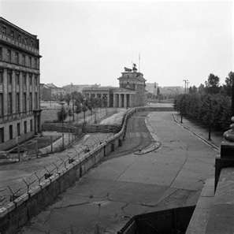
- Khrushchev also suspected the USA of sending spies into East Berlin and from there into the Eastern bloc through West Berlin.
- Khrushchev gave the USA a 6 month ultimatum to get out of Berlin or go to war.
- In 1959 there were two summit meetings at Geneva and Camp David to negotiate what to do with Berlin.
- The USA and USSR then met in May in 1960 at Paris to continue negotiations. However during the discussions an American U-2 spy plane got shot over the USSR and the pilot, Gary Powers was captured.

What happened at the summit meetings?

Geneva, May 1959 | Both sides put forward proposals for how Berlin should be governed, but no agreement was made. Eisenhower invited Khrushchev to the USA for talks
Camp David, September 1959 | No agreement made about a way forward with Berlin but the Soviets did agree to withdraw the ultimatum. Meeting appeared to establish better relations between the two leaders.
Paris, May 1960 | USSR announced that they had shot down an American U-2 spy plane as it flew over the Soviet Union. Eisenhower refused to apologize. Khrushchev walked out of the meeting and no decision was made.
Vienna, June 1961 | J.F.Kennedy became President of the USA. Khrushchev took a tough stance and renewed the Berlin Ultimatum of 1958. Kennedy was concerned by this but was determined not to appear weak. No final decision on Berlin was made.

Events: What happened?
- 13 August 1961 – The East Germans began building a wall around West Berlin. This was initially a barbed wire fence, which was gradually replaced with concrete.
- The Allies did nothing to stop the building of the Wall
- All movement between East and West was stopped.
- For several days Soviet and US tanks faced each other across the divided Berlin streets.

Outcomes: What were the consequences?
- The flow of refugees was reduced to a trickle. Between 1961 and 1989 (when the wall came down), only 5000 people managed to escape across it.

- Western nations were given a propaganda victory, as it seemed that communist states needed to build a wall to stop their citizens leaving.

- The wall became a symbol of the division of East and West.
- Peace was maintained, but at a price for the German people. Families were split, and travel restrictions made it very difficult for relatives to see one another
- Construction of the Berlin Wall led to a serious stand-off between the two superpowers
- President Kennedy worked behind the scenes to avoid conflict. He promised Khrushchev that if the Soviet Union removed its troops, the USA would do the same. This ended the stand-off

2.2 Cuban Missile Crisis, 1963

Origins of the crisis
Fidel Castro, a socialist, had overthrown the American-backed leader Batista in 1959. Cuba was only 90 miles off coast of America – they didn’t want a socialist (or worse, a communist) country ‘in their backyard’. USA tried to ruin Cuba by refusing to buy their main export – sugar. Facing financial collapse, Castro did a deal with the USSR – they would buy Cuba’s sugar crop. Cuba nationalised American companies and sold off US-owned property. The USA, aware that Castro had some connections to communism, refused to acknowledge his government. Castro removed US influence from Cuba and moved closer to the USSR

Bay of Pigs incident, 1961
- In 1961, the USA organized an attempt to overthrow Castro, known as the Bay of Pigs invasion
- Total failure for Kennedy
- The CIA had been convinced that the Cuban people would revolt against Castro
- BUT… they had underestimated his popularity, and there was no uprising.
- 1,400 Cuban exiles landed in Cuba BUT… they were met by 20,000 Cuban soldiers ready to defeat them and no support from the Cubans
- Disaster for Kennedy as Castro grew closer to the USSR and in May 1962, they agreed to station Soviet nuclear weapons on Cuba
- Castro also declared himself to be a Communist and asked Khrushchev to help defend Cuba against any future attacks from America

The Thirteen Day crisis, 1962

14th October 1962 | An American U-2 spy plane flies over Cuba and takes photos revealing that missile sites were being built
16th October 1962 | Kennedy was told that Khrushchev intended to build missile sites in Cuba
18th/19th October 1962 | Kennedy held talks with his closest advisers. The Hawks wanted an aggressive policy, whilst the Doves wanted a peaceful solution
20th October 1962 | Kennedy decided to impose a naval blockade around Cuba to prevent Soviet missiles and equipment reaching Cuba. The Americans searched any suspected ships carrying arms or missiles
21st October 1962 | Kennedy made a broadcast to the American people informing them if the potential threat and what he intended to do
23rd October 1962 | Khrushchev sent a letter to Kennedy insisting that Soviet ships would force their way around the blockade
24th October 1962 | Khrushchev issued a statement insisting that the Soviet Union would use nuclear weapons in the event of a war
25th October 1962 | Kennedy wrote to Khrushchev asking that he withdraws the missiles from Cuba
26th October 1962 | Khrushchev replied to Kennedy’s letter. He said he would withdraw the missiles if the USA promised not to invade Cuba and to withdraw its missiles in Greece and Turkey (they were doing this secretly)
27th October 1962 | A US spy plane was shot down over Cuba. Attorney General Robert Kennedy (brother of the President) proposed a deal with the Soviet Union. The USA would withdraw missiles from Turkey as long as it was kept secret
28th October 1962 | Khrushchev accepted the deal

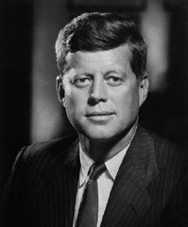
Consequences of the Cuban Missile Crisis
The superpowers had almost gone to a war: a war that would have destroyed much of the world. BUT… the crisis did actually lead to better relations

- A hotline was set up between Moscow and Washington so that the leaders could speak directly. This was to try and head off any future crises before they became serious.

- Khrushchev seemed to have failed – he had backed down in the face of American pressure.

- Kennedy became the hero of the Western world. The public did not know that Kennedy had secretly agreed to remove US missiles from Turkey.


- The two powers realised how close they had come to nuclear war. Arms talks began and a number of key treaties were signed:
  - Limited Test Ban Treaty (1963): both the USA and the USSR agreed to stop testing nuclear weapons above ground and underwater
  - The Outer Space Treaty (1967): the two superpowers, together with Britain and several other countries promised to use outer space for peaceful purposes and not to place nuclear weapons in orbit
  - The Nuclear Non-proliferation Treaty (1968): designed to stop the spread of nuclear weapons

- USA began selling grain to the USSR

2.3 The Soviet invasion of Czechoslovakia, 1968
Increased tension over Czechoslovakia
In the 1960s there was growing opposition to Soviet control for several reasons:
- Antonin Novotny had been the Czech leader since 1957. He was unpopular because he was a hardline communist who refused to introduce reform
- The Czech economy was in serious decline in the 1960s. This led to a fall in the standard of living.
- Many Czechs began to demand greater democracy, including Alexander Dubcek
- Dubeck elected in 1968 – Soviet leadership approved of Dubeck and trusted him to make the government of Czechoslovakia more effective and less unpopular
- Dubeck committed to the Warsaw Pact and a devoted Communist.
The Prague Spring
On April 5th 1968, Dubček (the leader of Czecoslovakia) embarked on a programme of reform that included amendments to the constitution of Czechoslovakia that would have brought back a degree of political democracy and greater personal freedom. These reforms became known as the Prague Spring.
Dubček announced that he wanted the Czech Communist Party to remain the main party in Czechoslovakia, but that he wanted the oppressive aspects of the party to be reduced. Communist Party members in Czechoslovakia were given the right to challenge party policy. In what became known as the ‘Prague Spring’, Dubček also announced the end of censorship and the right of Czech citizens to criticize the government. Newspapers took the opportunity to produce scathing reports about government incompetence and corruption. Trade unions were given increased rights to bargain for their members. Dubeck’s reforms were met with great enthusiasm by the Czech people
Soviet Response:
Dubček assured Moscow that Czechoslovakia would remain in the Warsaw Pact and that they had nothing to worry about with regards to the reforms.
This did nothing to reassure Soviet leader Brezhnev, especially after Romania was refusing to attend the Warsaw Pact meetings and the Yugoslavian leader, Tito, refused to accept control from Moscow.
- On the night of August 20th/21st troops from the Warsaw Pact invaded Czechoslovakia to reassert the authority of Moscow. There were 500,000 troops who entered Czechoslovakia and ended the Prague Spring
- Little opposition to the invasion
- Brezhnev had ordered the Czech army to remain in its barracks
- Czech people could not do anything to try and stop it, except some people who tried to block roads or attacked individual tanks
- Some others threw petrol bombs at the Soviet tanks as they moved through Prague. Buildings were set on fire
- Invading forces were told they had been invited to help restore law and order by the Czech government
- Dubeck and other leaders were arrested and taken to Moscow, and forced to accept the end of the Czech moves towards democracy
- Dubeck was replaced with Gustav Husak (1969), he was a hardliner loyal to Moscow and introduced a clampdown in which over a thousand Czechs were arrested
Consequences:
- The Prague Spring had proved that the Soviet Union was not willing to even contemplate any member of the Warsaw Pact leaving it. The Warsaw Pact remained strong – the USSR thought this was vital to the survival of communism in Europe.

- Brezhnev then outlined the Brezhnev Doctrine. This was a Soviet foreign policy which called for the use of Warsaw Pact forces to intervene in any Eastern Bloc nation which was seen to compromise communist rule and Soviet domination, either by trying to leave the Soviet sphere of influence or even moderate its policies. If one country’s actions threaten other countries, then it was the duty of those countries to take steps to stop those actions. This also redefined communism as a one-party state

- Invasion strained relations between other communist countries in Europe, especially as Yugoslavia and Romania condemned the invasion. The Communist Parties of Italy and France cut links to Moscow. Led to greater Soviet control of the members of the Warsaw Pact – reinforced by the Brezhnev Doctrine which emphasized that members of the Warsaw Pact were under close control of the Soviet Union

- The USA and other Western governments were outraged by the invasion and many of them made strong protests to the Soviet Union. There was an attempt to pass a formal resolution condemning the invasion in the UN but this was vetoed (by the Soviet Union). At the same time, the USA was involved in a costly war in North Vietnam and was also beginning to adopt a policy of détente with the Soviet Union. Other countries saw that the USA were keen to criticise the Soviet Union but much less prepared to take action

Check your understanding: Answer these quick fire questions
Berlin
1. Give two reasons why there was tension in Berlin by 1961.
2. How many people had travelled from east to west Germany between 1945-1960?
3. Why was the refugee crisis in Berlin called the ‘Brain Drain’?
4. What was the 6 moth ultimatum?
5. Which places did the USA and USSR meet in to negotiate about the future of Berlin?
6. Who was Gary Powers?
7. What happened on 13th August 1961?
8. What was the first barrier between east and West Germany made of?
9. How many people managed to escape from East Berlin between 1961 and 1989?
10. What did the wall become a symbol of?

Cuba

- What political ideology did Fidel Castro believe in?
- How close was Cuba to the USA
- How did the USA try to ruin Cuba after Fidel Castro took over?
- How many Cuban exiles invaded Cuba in 1961?
- Where did the Cuban exiles invade?
- What was the main consequence of the failed Bay of Pigs invasion?
- What did American spy planes notice on Cuba?
- How did Kennedy try to prevent missiles from reaching Cuba?
- What deal did Kennedy make to ensure missiles were not placed in Cuba?
- Identify two consequences of the Cuban Missile Crisis.

Czechoslovakia

- Who was the leader of Czechoslovakia?
- What year did the Prague Spring reforms take place?
- Where is Prague?
- Give two examples of Prague Spring reforms.
- What did Dubcek say about the Warsaw Pact?
- Who was the Soviet leader at this time?
- How did the Soviet Leader respond?
- What happened to Dubcek in April 1969?
- What happened to the Warsaw Pact?
- What was the Brezhnev Doctrine?

Exam questions
Question 1: Explain two consequences of … (8 marks).
Each consequence is marked out of 4 marks
 | Marks | Description
Level 1 | 1-2 | - Simple or generalised comment is offered about a consequence.  - Generalised information about the topic is included, showing limited knowledge and understanding of the period.
Level 2 | 3-4 | - Features of the period are analysed to explain a consequence.  - Specific information about the topic is added to support the explanation, showing good knowledge and understanding of the period.

Explain two consequences of the election of Alexander Dubeck as First Secretary of the Czech Communist Party in January 1968
Explain two consequences of the building of the Berlin Wall in 1961
Explain two consequences of the Hungarian crisis of 1956
Explain two consequences of the Prague Spring on relations between the Soviet Union and Czechoslovakia
Explain two consequences for international relations of the Soviet invasion of Czechoslovakia

Question 2: Write a narrative account analysing the key events of … (8 marks) You will be given two bullet points YOU MUST USE MORE…
Marks | Description
Level 1  1-2 | - A simple or generalised narrative is provided; the account shows limited analysis and organisation of the events included.  - Limited knowledge and understanding of the events is shown.
Level 2  3-5 | - A narrative is given, showing some organisation of material into a sequence of events leading to an outcome. The account of events shows some analysis of the linkage between them, but some passages of the narrative may lack coherence and organisation.  - Accurate and relevant information is added, showing some knowledge and understanding of the events.  Maximum 4 marks for answers that do not go beyond aspects prompted by the stimulus points.
3  6-8 | - A narrative is given which organises material into a clear sequence of events leading to an outcome.  - The account of events analyses the linkage between them and is coherent and logically structured.  - Accurate and relevant information is included, showing good knowledge and understanding of the key features or characteristics of the events.  No access to Level 3 for answers which do not go beyond aspects prompted by the stimulus points.

A step by step guide on how to write a narrative account:
1. Select the key events and developments for what the question is asking you…
2. Sequence them in the right order
3. Link them – how did one lead on from the other
Write a narrative account analysing the key events of the ‘Berlin Crisis’ in the years 1958-1961 (Berlin Ultimatum, 1958; the construction of the Berlin Wall)
Write a narrative account analysing the main events in East-West rivalry over Berlin, 1958-1961 (The Summit meetings; the building of the Berlin Wall)
Write a narrative account analysing the main events in superpower rivalry in Cuba in the years 1959 to 1962 (The Bay of Pigs invasion, 1961; the Cuban Missile Crisis, 1962)]
Write a narrative account analysing the key events of the Soviet invasion of Czechoslovakia in 1968 (The Prague Spring; the Soviet Union re-establishes control)

Question 3: Explain the importance of X for Y… (2 x 8 marks)
Choice of 3 bullet points
Mark | Description
1  1-2 | - A simple or generalised answer is given, showing limited development and organisation of material.  - Limited knowledge and understanding of the topic is shown.
2  3-5 | - An explanation is given, showing an attempt to analyse importance. It shows some reasoning, but some passages may lack coherence and organisation.  - Accurate and relevant information is added, showing some knowledge and understanding of the period.
3  6-8 | - An explanation is given, showing analysis of importance. It shows a line of reasoning that is coherent and logically structured.  - Accurate and relevant information is included, showing good knowledge and understanding of the required features or characteristics of the period studied.

Explain the importance of the summit conferences for the problem of Berlin

Explain the importance of the ‘Bay of Pigs’ invasion for relations between the USA and the Soviet Union

Explain the importance of Kennedy’s 1963 speech for the future of Germany

Explain the importance of the ‘Bay of Pigs’ incident for the future of Cuba

Explain the importance of the ‘Prague Spring’ for relations between the USA and the Soviet Union

Explain the importance of the Bay of Pigs invasion in the development of the Cold War

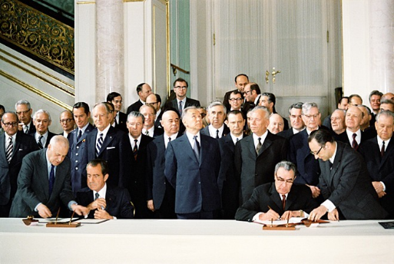
Key Topic 3: Détente & the End of the Cold War
Key Topic 3.1: Attempts to reduce tension between East and West
A number of treaties were signed in this period that reduced tension between the USA and USSR. This period became known as détente. Détente means the easing of tension.
In 1968, Nixon was elected as president of the USA and he was determined to take his country out of the Vietnam War, which had cost the USA billions of dollars, and resulted in the deaths of almost 60,000 American soldiers. USA also had large scale demonstrations going on about the war, and also there were Civil Rights issues.
Policy of détente would allow the USA to spend less money on weapons, and more on trying to deal with their own social problems.
The Soviet Union was also facing economic problems and wanted to cut spending on weapons and devote more money to improving living standards and updating is economy.
Willy Brandt (1969) was elected as Chancellor of West Germany and he wanted to focus on improving relations between East and West Germany.
SALT 1 (Strategic Arms Limitation Talks) 1972:
•Signed in 1972, it successfully limited the number of weapons they had.
•It imposed limits on the nuclear capability of the USA and USSR.
•They agreed there would be no production of ballistic missiles.
•Submarines would only be produced when the nuclear missiles ran out
•Significant because it was the first agreement between the superpowers that successfully limited the number of nuclear weapons they had
- Successfully slowed down the arms race
- Led to further negotiations
- Ensured that neither side had a decisive advantage in nuclear weapons
BUT… Did not cover intermediate nuclear weapons, which both sides continued to deploy in Europe during the late 1970s
Helsinki Conference 1975:
The USA and USSR, along with 33 other nations, made declarations about three distinct international issues (baskets):
•Security -> Recognition of Europe's borders - USSR accepted that West Germany existed and that it did not belong to them.
•Cooperation -> There was a need for closer economical, cultural and scientific links between the superpowers. This would lead them to closer political agreement.
•Human Rights -> Each superpower agreed to respect their citizens human rights. E.g. thought, speech etc.
This stabilised the situation in Europe as there was greater cooperation between the superpowers and their European allies. Helsinki represented the high point of détente, and at the same time, coincided with more US-Soviet cooperation like the Apollo Soyuz Test Project (1975) – a joint space mission
BUT… the Soviet Union continued to focus on Eastern bloc countries and to apply the Brezhnev Doctrine. It continued to treat protesters harshly. The USA also continued to priorities its interests in countries it could influence, like Chile and El Salvador.
SALT 2 (1979)
SALT 2 was an arms control agreement that marked the end of détente. Relations were worsening between the USA and USSR. Th USA were concerned over the 2,000 Soviet troops stationed in Cuba, and then in 1979, NATO decided to place long-range missiles in Europe. The treaty was never ratified due to the Soviet invasion of Afghanistan (1979).
- A limit of 2400 strategic nuclear delivery vehicles for each side
- A limit of 1320 multiple independently targetable re-entry vehicle (MIRV) systems for each side
- A ban on the construction of new land-based ICBM launchers
BUT… SALT 2 failed
- West German politicians opposed the treaty, as they feared it weakened the defense of West Germany. They thought that after the treaty, the USA would be less likely to use its nuclear weapons if West Germany were attacked by the Soviet Union
- Some US politicians thought that the treaty made too many concession to the Soviet Union
- US-Soviet relations soured after the Soviet invasion in 1979. The US Senate never approved the treaty, so it never became US policy

Key Topic 3.2 Flashpoints in superpower relations, 1979-1984
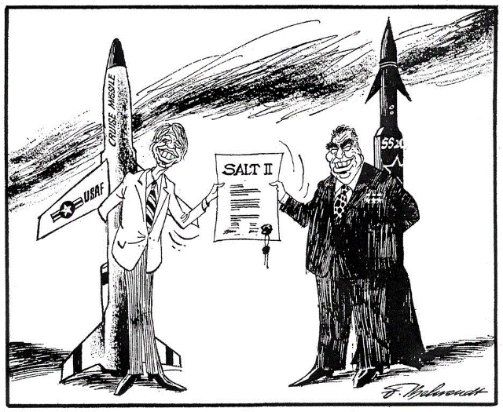
From 1977, talks for a new S.A.L.T (S.A.L.T. II) agreement took place. The aim was to limit every type of rocket and warhead.
It was meant to stay in force until 1985, and limited each superpower to 2,400 strategic nuclear weapon systems. The treaty was drawn up in 1979, but the USSR then invaded Afghanistan, so the USA refused to ratify the treaty.
Although it was never ratified, both sides pledged to follow its guidelines. However, it did not mention tactical (short-range) weapons or designate how many strategic warheads each side could deploy.
Soviet Invasion of Afghanistan (Dec 1979)
Causes:
In April 1978, a pro-Soviet government took control in Afghanistan and received economic assistance from Moscow. Toppled in September 1979 when Amin staged a popular coup. Moscow, at first, supported Amin, but his government became increasingly unpopular as other pro-Muslim factions tried to overthrow him. Brezhnev became worried when he heard rumours that he was talking to the USA about possible American support, so he decided to act.
Afghanistan was so important to the Soviet Union because it was bordering the Soviet Union. On 24th December 1979, 50,000 Soviet troops invaded Afghanistan, claiming that they had been invited in by Amin to support his government against terrorists. Amin was assassinated on 27th December, and replaced by a pro-Soviet Babrak Kamal. The Soviets remained in Afghanistan for almost ten years, fighting opponents of Babrak Kamal.
Why was the USA worried?
- USA did not want the Soviet Union to get more control in the Middle East
- A successful invasion of Afghanistan might mean Soviet influence in Iran
- Iran could block Middle East oil exports at the Straits of Hormuz – Middle East oil was essential to the USA’s prosperity.
How did the USA react?
- Soviet Union had invaded to protect its interests in a neighbouring state – like Czechoslovakia.
- Americans saw this as an example of the Soviet Union working to spread communism abroad, which the USA had tried to resist.
- Carter claimed the invasion posed the biggest threat to world peace since the end of WW2
Consequences of the Invasion (explained in detail below)
- Effectively ended détente and worsened relations. Many Americans felt that they could not trust the Soviet Union.
- Pressure was put on the Soviet leadership to end the increasingly unpopular war because more and more troops were dying
- SALT II ratification suspended. USA began to build up its own conventional and nuclear weapons. The US-Soviet arms race began to speed up again, as more nuclear weapons were produced and deployed
- USA stopped exportation of grain to USSR
- USA gave military and economic aid to Mujahedeen rebels fighting Soviet troops
- Boycotting of 1980 Moscow Olympics
- Led to the election of Ronald Reagan in the USA as Carter was ridiculed as weak and Reagan was very anti-Communist
Carter doctrine, January 1980
In response to Afghanistan invasion Carter was appalled by the Soviet aggression and released a statement that became known as the ‘Carter Doctrine’.
He stated the USA would:
- Not allow the USSR to gain control of the oil-rich Middle East.
- Take a number of immediate steps to try to remove Soviet troops from Afghanistan.
- Threatened to use force if the Soviet Union attempted to take control of the Persian Gulf
- Imposed economic sanctions – there would be no trade with the Soviet Union. This meant the USA would no longer export grain or import oil from the Soviet Union
- The USA and its allies, Saudi Arabia and Pakistan, secretly provided assistance to the Mujahedeen – the USA and its allies were directly backing a war against the Soviet Union
- USA ceased co-operating with the Soviet Union and began to confront it instead
The Olympic boycotts (1980/1984)
In protest against the invasion of Afghanistan, the USA led a boycott of the 1980 Olympic Games, which was held in Moscow. Over 60 nations supported the US boycott.
- Olympic Games are a global event which the Soviet Union was hoping to promote communism to the huge television audience.
- Boycott reflected the influence that the USA had in international affairs
- All countries looked forward to the Games – telling their athletes they were not allowed to end would not be an easy thing to do
- Boycott was successful because the Moscow Games looked second-class, with star athletes not featuring
- Soviet Union was extremely angry about this, they felt undermined and relations with the USA deteriorated even further
- ‘Second Cold War’
- Soviet Union reacted by trying to boycott the USA’s Olympics in Los Angeles in 1984; Soviet Union led a boycott of the games which was joined by 15 communist countries
Ronald Reagan and the ‘Second Cold War’
Reagan was elected as the new US president in January 1981. He was elected as he had a tough anti-communist stance; referring to the Soviet Union as ‘that evil empire’. He believed that Carter had been too soft on the Soviets. Reagan had been a hard line anti-communist and believed détente caused USA to lose ground with USSR; called Soviet Union ‘The Evil Empire’.
Reagan had no interest in détente and was prepared to confront the Soviet Union whenever possible. The US Congress agreed to Reagan’s demands for increased defence spending, which would cost more than a trillion dollars in the years 1981-1987.
The Strategic Defense Initiative (SDI) aka ‘star wars’
In 1983 US scientists began working in the SDI. This project was informally named ‘Star Wars’. The aim was to prevent Soviet nuclear missiles from reaching US targets by creating a huge laser shield in space. If successful, SDI would mean USA wouldn’t be victim of ‘first strike’. It also created a ‘gap’ in the arms race and would mean an end to M.A.D. Clearly this caused increased tension between the Superpowers.
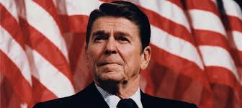
In 1982 meetings between the USA and USSR resumed under the banner of START (Strategic Arms Reduction Talks). Reagan demanded huge cuts in Soviet nuclear capability. In response, the Soviets pulled out of the talks. Reagan’s statements were very aggressive – this terrified the Soviets into thinking he was preparing the US to fight a war with them.
“I urge you to beware the temptation of pride --the temptation of blithely declaring yourselves above it all and label both sides equally at fault, to ignore the facts of history and the aggressive impulses of an evil empire, to simply call the arms race a giant misunderstanding and thereby remove yourself from the struggle between right and wrong and good and evil”.
1983 ‘Evil Empire’ Speech
USA invaded Grenada to stop Communist government from taking control. As a result the LA Olympics were boycotted by USSR and Communist countries because of Grenada invasion
The Soviet Union were concerned with SDI because it meant that they would have to spend even more money on armaments in order to compete with the USA. The Soviet economy was already experiencing problems and renewed arms spending may destroy t completely. Part of Reagan’s plan was that the Soviet Union would try to compete, and in doing so, the economy would collapse. The Soviet Union could no longer compete in the arms race.
Therefore, SDI proved to be a significant turning point in the arms race and the Cold War.

Key Topic 3.3 The collapse of Soviet control of Eastern Europe
Gorbachev’s new thinking 1985 (The beginning of the END)
Mikhail Gorbachev came to power in March 1985. He inherited a poor economy because of the Soviet War in Afghanistan lasting 10 years. He wanted to improve living standards for those in the USSR. He pushed for reforms to change the USSR’s government spending habits and allow a more open society. Gorbachev thought the best way to solve economic problems was to rebuild economy from scratch. He argued it was necessary to for government to be more flexible and allow some private ownership of property and business. He introduced the twin policies of Perestroika (economic restructuring) and Glasnost (openness & free speech). Gorbachev wanted more openness to halt the constant falsification of government figures. The powers of the KGB (secret police) were limited and criticism of government was permitted
Gorbachev also understood that the Soviet economy was under immense pressure and the huge investment on military spending severely limited state support for its own people so he also wanted to change foreign policy
“We are not abandoning our convictions, our philosophy or traditions, nor do we urge anyone to abandon theirs.” (Gorbachev speaking in 1988)
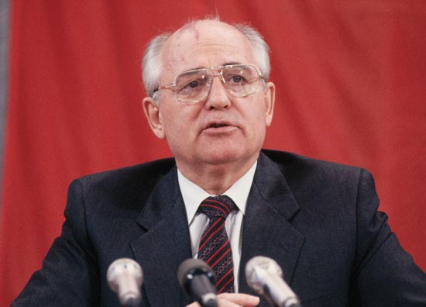
- Reduce defence spending
- Avoid danger of nuclear war
- Not to interfere with the running of countries outside Soviet Union
- Realised USSR was bankrupt and could not afford arms race with USA
- Withdrew Soviet troops from Afghanistan
- Reduced Soviet aid worldwide (previously the USSR supported communist countries worldwide through COMECON)
- Sought détente to reduce spending on defence and to be able to borrow money
The summit meetings
Geneva, November 1985 | Although nothing was decided, the Geneva Accord was set out which committed the USA and Soviet Union to speed up arms talks. Both Gorbachev and US President Ronald Reagan promised to meet up in the near future. It was clear that the two men had got on well. After discussing policy, Reagan invited Gorbachev to go with him to a beach house, which was strictly against rules. But Gorbachev went, and the two leaders spoke well over their time limit and came out with the news that they had planned more summits
Reykjavik, 1986 | Leaders did fail to reach an agreement on arms limitations, but there was still evidence that the leaders were getting on well
Washington, December 1987 | Gorbachev had not accepted the USA were not going to scrap SDI. Led to the signing of the INF Treaty (Intermediate-Range Nuclear Force).
Malta Summit, 1989 | Gorbachev met the new President, George Bush. No agreements were made but both the USA and the Soviet Union saw this meeting as marking the end of the Cold War. Gorbachev said, "I assure the President of the United States that I will never start a hot war against the USA."  In 1989 Gorbachev ended the Russian invasion of Afghanistan and pulled out all remaining soldiers. He pressured the chancellor of East Germany (Honecker) to give more freedom to East Berliners, which eventually led in 1989 to the collapse of the Berlin Wall  The Warsaw Pact dissolved, and was replaced by the Commonwealth of Independent States (CIS), with Russian Republic as dominant member
INF Treaty (Intermediate-Range Nuclear Forces), 1987
In 1987 Gorbachev signed the Intermediate-Range Nuclear Forces Treaty with the USA, which banned all nuclear and conventional ballistic missiles that could travel between 500-5,000 miles. This was a revolutionary event, and signaled the end of the Cold War.
The collapse of the Soviet Union
Gorbachev announced that the Soviet Union was going to give up the Brezhnev Doctrine, the Soviet satellite countries were now free to choose how they would be governed. They no longer had to fear that the Soviets would intervene as they had in Hungary (1956) and Czechoslovakia (1968).
Gorbachev’s reforms within the Soviet Union, restructuring the economy and introducing more openness to the government, further encouraged the people of the satellite states to introduce changes that would improve their standard of living and increase their individual freedoms.
The reforms were not intended to bring an end to communism – designed to introduce reforms that would strengthen communist governments – BUT… it actually led to the dismantlement of Soviet control throughout Europe.

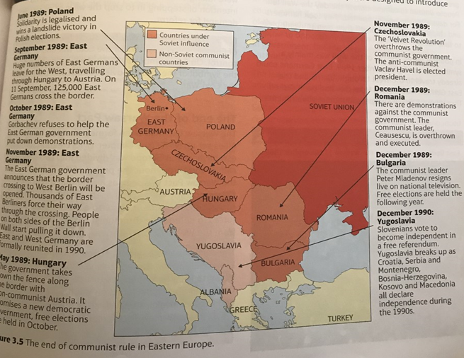
The significance of the fall of the Berlin Wall, November 1989
- 9th November 1989, the East German government announced the opening of the border crossings into West Germany.
- The people began to dismantle the Berlin Wall
- On a personal level, the fall of the Wall meant that the people of Germany could be reunited with friends and relatives who they had not seen for almost 30 years. 1 million people had seized the chance to see relatives and experience life in West Germany
- Politically, the fall of the Wall was a symbolic event. By November 1989, East Germans could already travel to the West through Austria and the East German leaders Erich Honecker had been sacked.
- For 30 years, the Berlin Wall had stood for the division of Europe – it was a symbol of the Cold War and of Soviet control – its destruction marked the end of Soviet control and the end of the Cold War.
The end of the Warsaw Pact
- The creation of the Warsaw Pact established that Europe was divided into two armed camps. It was a symbol of Soviet dominance in Eastern Europe, and it allowed the Soviet Union to keep an eye on its communist allies.
- Events of 1989 saw communist governments coming under pressure across Eastern Europe and made it impossible for the Warsaw Pact to survive.
- Military co-operation between the member states ended in early 1990 and the Pact was formally dissolved in July 1991.
Europe becomes reunited
- Break-up of the Warsaw Pact indicated that the division between democratic West and communist East was now gone.
- Cold War was over, and there was no longer two armed alliances confronting each other across the Iron Curtain
- Satellite states began to regain their independence, as they no longer had to follow the policies created in Moscow, or run their economies to benefit the Soviet Union
- Every single member of the Warsaw Pact abandoned Communism
Goodbye Gorbachev
- Felt he had done too little to stop the fall of communism in Eastern Europe – saw this as an act of weakness
- The economic reforms, perestroika, he had introduced had had no immediate effect: still food shortages and rising prices
Other Russians wanted the complete collapse of the communist system. In February 1990, 250,000 people demonstrated against the communists in Moscow. In the annual May Day parade in Moscow’s Red Square, Gorbachev was booed!
In August 1991, hard-liner communists led a coup against Gorbachev. They imprisoned him in his own dacha (country home) in the Crimea. To seemed as though the USSR was about to return to the bad old days, when reform movements were stamped out by the communists.
Boris Yeltsin wanted to destroy Soviet communism and led a demonstration against the coup. He insisted that reform had to continue in order for Russia to be saved. Yeltsin was seen as hero who would save Russia from a slide back into communism repression. He was also seen as the man with the power.
He formally ended the USSR in December 1991. Later in the same month, Gorbachev resigned as Soviet president (there was no longer a Soviet Union for him to be president for). The communist red flag that flew over Kremlin was lowered for the last time.

1. What is the meaning of Détente?
2. Describe 2 key terms of the SALT 1 Treaty
3. What treaties were signed in 1975?
4. What did the USA and USSR agree about security at Helsinki in 1975?
5. What did the USA and USSR agree about cooperation at Helsinki in 1975?
6. What did the USA and USSR agree about human rights at Helsinki in 1975?
7. What talks began in 1977?
8. What happened in April 1978?
9. Why did the Soviets invade Afghanistan?
10. Identify 2 consequences of the Soviet Invasion of Afghanistan
11. Who supported the Mujahedeen?
12. Identify 2 points about the Carter Doctrine.
13. Who were the leaders of USSR and USA at this time during the Cold War?
14. What did Reagan describe the USSR as?
15. What was SDI?
16. Why were the LA Olympics boycotted?
17. What were the two policies Gorbachev introduced?
18. What does Perestroika mean?
19. What does Glasnost mean?
20. Why did Gorbachev want to introduce his two new policies? Give two reasons.
21. Which three Baltic States declared themselves independent from the USSR in 1990?
22. Why did some people dislike Gorbachev?
23. What happened in February 1990?
24. What happened to Gorbachev in 1991?
25. What did Yeltsin do?
26. Who resigned Christmas Day 1991?
Exam questions
Question 1: Explain two consequences of … (8 marks).
Each consequence is marked out of 4 marks
 | Marks | Description
Level 1 | 1-2 | - Simple or generalised comment is offered about a consequence.  - Generalised information about the topic is included, showing limited knowledge and understanding of the period.
Level 2 | 3-4 | - Features of the period are analysed to explain a consequence.  - Specific information about the topic is added to support the explanation, showing good knowledge and understanding of the period.

Explain two consequences of Mikhail Gorbachev’s decision to abandon the Brezhnev Doctrine
Explain two consequences of Gorbachev coming to power in the Soviet Union
Explain two consequences of the Soviet invasion of Afghanistan
Explain two consequences for relations between the USA and the Soviet Union of Reagan becoming president
Explain two consequences of Gorbachev’s ‘new thinking’ on Eastern Europe

Question 2: Write a narrative account analysing the key events of … (8 marks) You will be given two bullet points YOU MUST USE MORE…
Marks | Description
Level 1  1-2 | - A simple or generalised narrative is provided; the account shows limited analysis and organisation of the events included.  - Limited knowledge and understanding of the events is shown.
Level 2  3-5 | - A narrative is given, showing some organisation of material into a sequence of events leading to an outcome. The account of events shows some analysis of the linkage between them, but some passages of the narrative may lack coherence and organisation.  - Accurate and relevant information is added, showing some knowledge and understanding of the events.  Maximum 4 marks for answers that do not go beyond aspects prompted by the stimulus points.
3  6-8 | - A narrative is given which organises material into a clear sequence of events leading to an outcome.  - The account of events analyses the linkage between them and is coherent and logically structured.  - Accurate and relevant information is included, showing good knowledge and understanding of the key features or characteristics of the events.  No access to Level 3 for answers which do not go beyond aspects prompted by the stimulus points.

A step by step guide on how to write a narrative account:
1. Select the key events and developments for what the question is asking you…
2. Sequence them in the right order
3. Link them – how did one lead on from the other
Write a narrative account analysing the key events of détente in the years 1970-1979 (SALT 1, 1972; The Helsinki Accords, 1975)
Write a narrative account analysing the ways in which relations between the USA and the Soviet Union worsened in the years 1979-1985 (Soviet invasion of Afghanistan, 1979; Strategic Defence Initative)
Write a narrative account analysing the key events leading to the break-up of the Warsaw Pact in the years 1985-1991 (Gorbachev became leader of the Soviet Union in 1985; the fall of the Berlin Wall in 1989)
Write a narrative account analysing the key events in attempts to reduce tension between East and West in the 1970s and 1980s (The Helsinki Agreements’ Gorbachev’s ‘new thinking’)
Write a narrative account analysing the main developments in the collapse of the Berlin Wall during 1989 (the impact of Sinatra Doctrine; developments in East Germany)
Write a narrative account analysing the key events in the Soviet Union and Eastern Europe in the years 1989-1991 (the impact of ‘new thinking’; the fall of the Berlin Wall)

Question 3: Explain the importance of X for Y… (2 x 8 marks)
Choice of 3 bullet points
Mark | Description
1  1-2 | - A simple or generalised answer is given, showing limited development and organisation of material.  - Limited knowledge and understanding of the topic is shown.
2  3-5 | - An explanation is given, showing an attempt to analyse importance. It shows some reasoning, but some passages may lack coherence and organisation.  - Accurate and relevant information is added, showing some knowledge and understanding of the period.
3  6-8 | - An explanation is given, showing analysis of importance. It shows a line of reasoning that is coherent and logically structured.  - Accurate and relevant information is included, showing good knowledge and understanding of the required features or characteristics of the period studied.

Explain the importance of the Soviet invasion of Afghanistan for relations between the USA and the Soviet Union
Explain the importance of the nuclear arms race for relations between the USA and the Soviet Union
Explain the importance of the Soviet invasion of Afghanistan for relations between the USA and the Soviet Union
Explain the importance of Ronald Reagan for relations between the USA and the Soviet Union
Explain the importance of the INF Treaty for relations between the USA and the Soviet Union
Explain the importance of the importance of the Helsinki Agreements (1975) for superpower relations.

Model answers
  - Explain two consequences of the decisions made by The Grand Alliance at the Yalta Conference in February 1945 (8 marks)

One consequence of the decisions made by The Grand Alliance at the Yalta Conference was would what would happen to Germany after the war. As a result of the conference, Germany was divided into four zones, controlled by Britain, the USA, the Soviet Union and France. Each country had the right to govern its sector as it saw fit. Stalin believed that in the end he had been given the poorest zone and resented the fact that the Western Allies administered the wealthier parts. This led to worse relations between East and West as Germany became an area of tension.

A second consequence was that there was an increase in suspicion between Stalin and the USA/Britain. This suspicion was as a result of the failure to agree on how Poland should be governed. There was general agreement that a government would be elected using free elections, but this meant different things to each country. To Stalin it meant using his influence to ensure a pro-Moscow government. Britain and the USA supported the London Piles who were non-Communists. Stalin wanted a Communist government in Poland as part of his plan to build a buffer zone. He saw the action of Britain and the USA as trying to undermine the security of the Soviet Union, so consequently, relations worsened.

  - Write a narrative account analyzing the key events leading to the break-up of the Warsaw Pact in the years 1985-1991. You may use the following in your answer
    - Gorbachev becoming leader of the Soviet Union in 1985
    - The fall of the Berlin Wall in 1989
You must also use information of your own (8 marks)
The break-up of the Warsaw Pact probably started when Gorbachev came to power in the Soviet Union. Although he did not intend to end Soviet domination of Eastern Europe, Gorbachev decided that the Soviet Union could not continue to spend huge sums of money of the arms race and foreign policy. Because of this, in 1985, he announced that the Soviet Union was abandoning the Brezhnev Doctrine.
As a result, the members of the Warsaw Pact realised they could not introduce reforms in their countries, without fear of being invaded by Warsaw Pact forces like Hungary and Czechoslovakia. So when, in September 1989, East Germany started travelling to West Germany through Hungary and Austria little was done to stop them. The countries of Eastern and Western Europe was becoming more connected. In the same month, the communist government in Poland was replaced after earlier being defeated in free elections. In October, communist government came to an end in Hungary. Moscow made no attempt to prevent the Polish elections or get rid of the new non-communist leaders in either country. Since the Warsaw Pact existed mainly to protect its communist members from the West, the reasons for its existence was fading away.
The fall of the Berlin Wall in 1989 made it even clearer that East and West were not divided any more. Its fall was symbolic and encouraged further challenges to communist rule. Communist regimes in Czechoslovakia and Romania were also toppled shortly afterwards. By the summer of 1990 all the old communist governments that had been democratically elected. With most countries of Eastern Europe now being led by non-communist governments there was no need for the Warsaw Pact, and as a result it was dissolved in July 1991.

  - Explain two of the following:
- 3.1 The importance of the Hungarian Uprising (1956) for the development of the Cold War
- 3.2 The importance of the Cuban Missile Crisis (1962) for relations between the USA and the Soviet Union
- 3.3 The importance of the Olympic boycotts for relations between the USA and the Soviet Union (16 marks)
3.1: The Hungarian Uprising was important for the development of the Cold War because it demonstrated Soviet determination to maintain control in Eastern Europe and worsened relations between the two superpowers. In October 1956, demonstrations against Soviet control began, Khrushchev sent troops and tanks to Budapest to try and restore peace. On 26h October Nagy was reinstated as prime minister. Nagy held talks with the Soviet Union as it was agreed the tanks would be withdrawn. On 31st October, Nagy’s proposed reforms were published. His most controversial reform was his intention to withdraw Hungary from the Warsaw Pact. On 4th November, Khrushchev decided that Nagy had gone too far, and 1000 Soviet tanks rolled into Hungary with 200,000 Soviet troops. Nagy was replaced with Kadar, and Nagy was shot and arrested. There was very little the West could do, apart from condone the actions of the Soviet Union. Hungary was too far away for military intervention, and if the USA did help, like Hungary had requested, it would be seen as an aggressive measure, and the Soviet Union could have launched their atomic weapons. The crisis was important because it highlighted the determination of the Soviet Union to maintain its control of Eastern Europe and prevent any further attacks on Communist control. It was also important because it intensified superpower rivalry The USA was furious with the brutality of the Soviet Union.
3.3: By the time of the Soviet invasion of Afghanistan, détente was coming to an end. As a result of the invasion, the Americans issued the Carter Doctrine and looked for ways to show their disapproval of the Soviet Union. Boycotting the Moscow Olympics provided an excellent opportunity. This really upset the Soviet Union because it was hoping to use the Olympics to show everyone how great communism was and how successful athletes from Warsaw Pact countries were – proving that Communist societies were better. The American boycott was important because t made it plain to the Soviet Union that the period of co-operation was over and that the USA still considered itself as the leader of the democratic world, ready to resist attempts to spread communism.
Equally, the Moscow boycott angered the Soviet Union which retaliated by leading the Warsaw Pact countries in a boycott of the Los Angeles Olympics in 1984. This showed that the world was still divided into two camps – East and West. The Olympic boycotts made the Cold War colder and showed that the USA and the Soviet Union were still bitter rivals.

