Who were the different groups who lived in Whitechapel and what social and political problems existed in this area?
Learning Objectives for this unit
- To examine the social make up of Whitechapel.
- To be able to describe the various groups who lived there and where they lived.
- To know, and be able to describe, new ideas which emerged in this area as a result of immigration from Eastern Europe, Ireland and other areas.
- To be able to describe, and explain, the various tensions which existed as a result of immigration and the social make up of this area.
Establishing an overview of where people lived and why
Glue your colour map in here and use it to answer questions 1 to 3about the locations that are highlighted.
1. This is the area around Flower and Dean Street. Why do you think that the Jewish immigrants of the 1880s and 1890s were drawn to this area? …………………………………………………………...
…………………………………………………………………………………………………………………..…………………………………………………………………………………………………………………..

2. The colour shading of this area shows that the Jewish population was almost 100%. Why would any new immigrants choose to group and live together? ………………………………………………..
…………………………………………………………………………………………………………………..…………………………………………………………………………………………………………………..

3. This is where the Peabody Estate was located, why didn’t the Jewish immigrants move to these new model apartments? ……………………………………………………………………………………..
…………………………………………………………………………………………………………………..…………………………………………………………………………………………………………………..
4. Now watch the video clip and note down how Fagin is portrayed. Please note, this portrayal does not reflect the view of the Upton Hall History Department…………………………………………
………………………………………………………………………………………………………………….
…………………………………………………………………………………………………………………..
5. What could be the connection between what you watched in the video and your answers to questions 2 and 3? …………………………………………………………………………………………...
…………………………………………………………………………………………………………………..

GROUP | WHY THEY CAME |  | THEIR EXPERIENCE
French  Huguenots (a type of Protestant) | 50,000 French Huguenots fled France during the religious wars, in the 17thand 18thC. However, by the mid 19th Century their numbers fell 20,000 as many had moved to the work in the Midlands weaving and cotton industry. |  | They settled in the Spitalfields area of the East end and their main profession was weaving. At first, their language and their Huguenot churches caused them to stand out. Over time, however, the Huguenots assimilated into English society. There was a drift towards the Anglican Church, and names were anglicized - Ferret became Ferry, and Fouache became Fash - often due to mistakes made by English clerks!
Irish | With an agricultural economy at home, many Irishmen had come to London in the 18th century for better-paid agricultural work in the summer and casual labour along the river in winter. | By the end of the 18th century, there was a substantial Irish population in Spitalfields at the East End of Cable Street, which became known as Knockfergus. The community was disliked for having linguistic and religious differences to the English. The eccentric MP, Lord George Gordon, instigated anti-Catholic riots in 1780, and it led to violent attacks on the homes of Irish Londoners there. By the time the smoke cleared on the Gordon Riots, 700 were dead. The Irish population grew tremendously in the East End between 1841 and 1851. The first settlers planned to move to America, but they ran out of money before they could find a ship to take them there. In London there were labouring jobs available on canals, roads, railways and the docks. The men working here became known as ‘navigators’, or ‘navvies’. Violence within this community was commonplace, especially because it was often alcohol fuelled. This made the Irish community even more unpopular.
Jewish | There was a Jewish community in London since the mid 1600s, but a new influx came after the collapse of Poland in 1835 when Jews were barred from professions and trades. In the mid 1800s, Spitalfields became home for Dutch and German, and later for poor Polish and Russian Jews. By 1871 the East End was home to about 1,000 Dutch or Polish Jews. Another wave of Jewish immigrants from Eastern Europe came to Whitechapel after 1881, when the assassination of Tsar Alexander II in Russia was followed by legal and government supported discrimination and atrocities against Jewish people, known as ‘Pogroms’. As similar treatment of Jews spread through Germany and Poland, more Jews came to Britain. By 1891 approximately 30,000 had arrived, and the Jewish population of parts of Whitechapel had grown to 95% of the total population. | The Jewish community lived and worked together in Whitechapel, Mile End, Stepney and Spitalfields. Brick Lane, which passes through Spitalfields, was inhabited in the 1880s mostly by Orthodox Jewish immigrants from Eastern Europe. By the early 1890s a number of shuls (synagogues) and chevrots (small places of worship) had been opened in Spitalfields and the neighbouring areas. The Jews' Temporary Shelter was created in 1886 at Leman Street for new immigrants arriving in London from Eastern Europe. Whitechapel therefore became a self-segregated community, as the Jewish settlers chose to live separately from others. They were widely resented for their cultural differences and for attitudes to work and business that were different to those of their neighbours:  • Compared to working-class locals, foreign Jewish workers seemed to quickly to find employment or set up businesses.  • Some established Eastern European immigrant ts preferred employing newer arrivals to locals. New arrivals were desperate for work and would accept lower wages in order to gain a job.  • Many Jewish immigrants ran tailoring businesses on the sweatshop model. Businesses that followed government rules about fair working conditions had to charge more for their products, so they could not compete with the lower prices of the sweatshop owners.  • Jewish people had their holy day on Saturday, so unlike other locals, they were free to work on Sundays. Local shopkeepers felt that Jewish demands for Sunday trading were an attempt to drive them out of business.Religious and cultural rules about food and clothing made the new immigrants stand out; and as the new immigrants settled near more established immigrants, there was no urgent need for them to learn English. Locals were therefore suspicious of the unfamiliar customs and languages and resented their success.
Who made up the immigrant population of Whitechapel?
Code the headings and highlight your notes:

Group

Size of this group

Activities that made this group stand out.

Response of others to this group.


Now use your information to answer this four mark question on p16 of your source booklet.
Describe two features of the population in Whitechapel. (4 marks)

Examining attitudes towards immigrants in Whitechapel
Read the source below and use the grid to help you to examine it. Don’t forget to add your own detailed knowledge in a pen of a different colour.
From Arnold White’s book, The Modern Jew, published in 1899.
There are thousands of [Jews] who prefer existence without physical exertion, and who are content to live on others, untrammelled (bothered) by considerations of honesty or truth … [consider] the benefit that the country would derive from the total cessation (stopping) of the immigration of professional paupers, anarchists (a political group) and thieves.

Content | Nature
Origins | Purpose

1. What does Arnold White accuse Jewish people of being?…………………………………………
……………………………………………………………………………………………………………………..
……………………………………………………………………………………………………………………..

2. What factors and evidence would make you question the accuracy of his portrayal?
……………………………………………………………………………………………………………………..
……………………………………………………………………………………………………………………..
……………………………………………………………………………………………………………………..
……………………………………………………………………………………………………………………..

3. What would you say that this source was useful for and why?
……………………………………………………………………………………………………………………..
……………………………………………………………………………………………………………………..
……………………………………………………………………………………………………………………..
……………………………………………………………………………………………………………………..
……………………………………………………………………………………………………………………..

4. What sources of evidence could you use to follow up on Arnold White’s book to test his opinion against reality? ………………………………………………………………………………………
……………………………………………………………………………………………………………………..
……………………………………………………………………………………………………………………..
……………………………………………………………………………………………………………………..
……………………………………………………………………………………………………………………..
Prejudice towards the immigrants of Whitechapel was worsened by their links to political groups.
Name of group | Origins of Beliefs | Beliefs | What activities had been undertaken by this group? | Which immigrant groups were linked to this?  What actions were taken as a result?
Fenians | Irish Nationa-lism and a desire to be free from British government control of Ireland. | ‘Home Rule’ (self-government) and preferably total independence from Britain. | Fenian Dynamite Campaign 1867–1885  13 December 1867: "Clerkenwell Outrage": A bomb exploded at New Prison in Clerkenwell, killing twelve passers-by.  15 March 1883: Bombs exploded at government buildings at Whitehall, Scotland Yard, and The Times.  25 February 1884: A bomb exploded at Victoria station, London. Other bombs were defused at Charing Cross station, Ludgate Hill station and Paddington station.  30 May 1884: Bombs exploded at the headquarters of the Criminal Investigation Department (CID) and the Metropolitan Police Service's Special Irish Branch; another bomb was planted at the foot of Nelson's Column but failed to explode.  2 and 20 January 1885: Bombs exploded  at Gower Street station, London.  24 January 1885: Bombs exploded at the House of Commons, the Tower of London and London Bridge. Two police officers and four civilians were injured. Two men were sentenced to penal servitude for life as a result. This was known as ‘Dynamite Saturday’. | Irish immigrants were all seen as probable Fenians and potential traitors.  A new department of the Metropolitan Police Force, known as Special Branch, was formed to counter Irish terrorism.
Anarchists | Russian revolution-aries. | To overthrow existing governments so that people could live without laws.  Greater rights for workers’ unions. | Attempted but failed revolution in Paris in 1871. The leaders then fled to England.  Most Anarchists operated within existing Socialist groups. An Anarchist Congress was held in London in 1881.  There were rumours that Nikolay Vasiliev, a Russian anarchist Jew and violent murderer, was now living in England; although there is little proof that this person even existed.  However, any bomb related violence did not start until 1894, (after the period that we are studying) with an attempted attack at Greenwich Observatory. | Russian and Eastern European Jews were considered to be potential radical anarchists. In 1893, Special Branch began an undercover surveillance of Eastern European revolutionaries.
Socialists | Marx and Engels | Better rights for workers.  Fairdistribution of wealth via nationalisationof industries and ending capitalism. | 1881 - The Socialist Democratic Federation (SDF), the first socialist party in Britain, was founded to represent agricultural, industrial and women’s rights.  1885 - Establishment of the International Worker’s Educational Club at Berner Street (see *on your map). The club had its own newspaper called the Arbeter Fraint or Worker’s Friend.  1887 - The Trafalgar Square demonstration and Bloody Sunday.  1888 – Elections were held for the new London County Council. There was a strong chance that Whitechapel would get an SDF councillor. | German and middle European Jews.  There was tension between the SDF and the police. The SDF wished to show the police as hopeless in order to illustrate how incompetent the government were.

1800
1700
1600
1800
1700
Create two timelines on this page.
On the first, record the phases of arrival of the different immigrant groups to Whitechapel..
On the second, record the activities of the Fenians, the Anarchists and the Socialists.

1600
What happened at Trafalgar Square on Bloody Sunday?

The Social Democratic Federation (SDF) organised a meeting for 13th November, 1887 in Trafalgar Square to protest against the policies of the Conservative Government headed by the Marquess of Salisbury. Sir Charles Warren, the head of the Metropolitan Police wrote to Herbert Matthews, the Home Secretary: "We have in the last month been in greater danger from the disorganized attacks on property by the rough and criminal elements than … for many years past. The language used by speakers at the various meetings has been more frank and open in recommending the poorer classes to help themselves from the wealth of the affluent." As a result of this letter, the government decided to ban the meeting and the police were given the orders to stop the marchers entering Trafalgar Square.

The SDF decided to continue with their planned meeting with Henry M. Hyndman, John Burns and Robert Cunninghame-Graham being the three main speakers. Some 30,000 persons, encircled Trafalgar Square as at least 10,000 protesters marched in from several different directions.

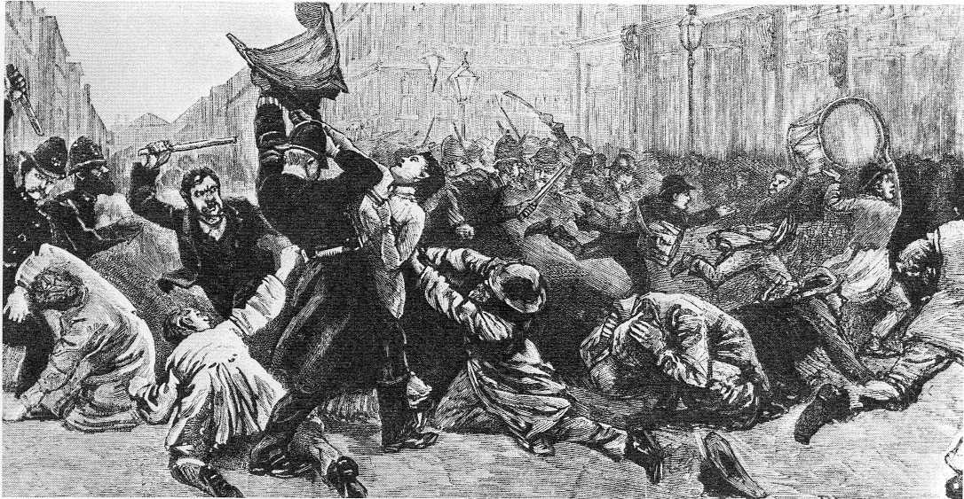
Two thousand police and 400 troops were deployed to halt the demonstration. Burns and Cunninghame-Graham were arrested and imprisoned for six weeks. Although the infantry were marched into position with bayonets fixed, they were not ordered to open fire and the cavalry were not ordered to draw their swords. In the fighting, many rioters were injured by police truncheons and under the hooves of police horses. Approximately 400 were arrested, and 50 were detained in custody. Both sides claimed that they had suffered the worst injuries.

The following Sunday, 20 November, saw another demonstration and more casualties. According to a report in the partisan Socialist Review, among them was a young clerk named Alfred Linnell,who was run down by a police horse, dying in hospital a fortnight later.The funeral of Linnell on 18 December provided another focus for the unemployed and Irish movements. William Morris, leader of the Socialist League, gave the main speech and
A depiction of the event from The Illustrated London News, showing a Policeman grabbing a banner from a woman whilst a member of the public attempts to club him.
"advocated a holy war to prevent London from being turned into a huge prison".A smaller but similar event
marked the burial of another of those killed, W. B. Curner, which took place in January. The release of those imprisoned was celebrated on 20 February 1888, with a large public meeting.
- Read the account above and highlight all names in one colour and dates in another.
- Who was to blame? Find evidence in chronological order to complete this chart.
The Government and Police | The Protesters

3. How would this event increase tension regarding:
The poor of Whitechapel.
Anarchists.

Socialists.

The Jewish community in Whitechapel?
How did the Government and the Media increase the tension in Whitechapel?
By 1888, the high unemployment and acute housing difficulties in the East end of London was causing friction between all the different groups living in Whitechapel. The work at the Peabody buildings had not benefitted those in the greatest need and the efforts of charities such as Barnado were insufficient to cope. There was intense competition between the local communities and the immigrant population and within the immigrant group itself. Street violence frequently broke out between the Eastern European and Irish groups, making some areas particularly violent. Anti-semitic attitudes and beatings of Jewish people became common.

Increased tension and violence focussed national attention on immigration and two parliamentary committees were formed to investigate. One of these investigations focussed on the illegal sweat-shop system, in which many newly-arrived Jewish immigrants were employed.
THINK: Do you find this manipulative at all?
……………………………………………………………………………………………….
Would this evidence help to relieve or exacerbate the tension in Whitechapel?
………………………………..………………………………..
………………………………..
………………………………..
………………………………..
………………………………..

Source D: Evidence given to the House of Lords Committee on Sweated Trades in 1890, by Charles Freak, secretary of the Shoemaker Society, a trade union representing workers in the industry.
There is no feeling against these foreigners as foreigners. These Jew foreigners work in our trade at this common labour for 16 or 18 hours a day, and the consequence is that they make a lot of cheap and nasty stuff that destroys the market and injures us [because it is sold at such a low price]. The Jewish labourers cause the defeat of English workmen in their battle to attain higher wages. They do this by shameless blacklegging during disputes [working during strikes] and taking work at any price.
In addition, Police acting on behalf of the government also experienced difficulties with language barriers.
THINK: How would language barriers exacerbate the tension in Whitechapel?
………………………………..………………………………..
………………………………..
………………………………..
………………………………..
………………………………..
………………………………..
………………………………..
………………………………..

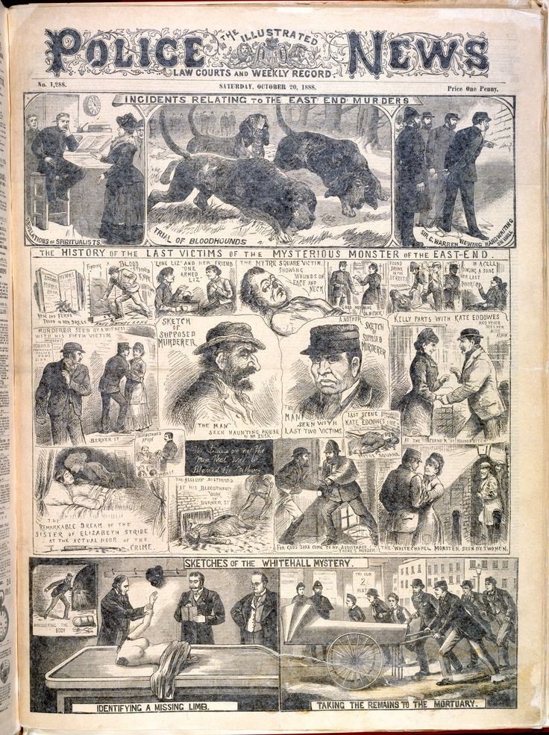
Finally, newspapers such as The East London Observer and the Pall Mall Gazette published sensationalised anti-Jewish features, whilst Lloyd’s Weekly Newsand the Illustrated Police Newsproduced stereotyped caricatures of Jews with hooked noses, dark beards and large, dark hats.
Source E: From a memorandum by Superintendent Mulvaney of H Division, sent to Scotland Yard in 1904, suggesting hismen should learn Yiddish (a language spoken by Eastern European Jews).
Bills [posters] and circulars in this language are distributed and posted all over the division [area patrolled by his men], but police know nothing of their purpose unless an interpreter is employed to translate them. As it is known that a number of these people are members of Continental Revolutionary Societies it would be very desirable to have members of the Service who could speak this language.
THINK: How would this manipulate public attitudes?
………………………………..………………………………………………………………..………………………………..………………………………
How would this exacerbate the tension in Whitechapel?
………………………………..………………………………………………………………..………………………………..………………………………

How did the social, political and economic situation lead to tension in Whitechapel?
Complete your hexagon activity below.


Consolidate your knowledge
Tensions in Whitechapel
Key word or event | Details about this / Significance to this study unit.
Huguenot
assimilated
Fenian
Home Rule
Fenian Dynamite Campaign
Dynamite Saturday
Special Branch
Knockfergus
Jewish
Self-segregated
Pogroms
Anti-semitic
Arnold White
Shul
Chevrot
Yiddish
Anarchist(s)
Nikolai Vasiliev
Socialist(s)
Social Democratic Federation
International Worker’s Educational Club
Bloody Sunday
East London Observer
Pall Mall Gazette
Lloyd’s Weekly News
Illustrated Police News
Illustrated London News
Marquis of Salisbury
Sir Charles Warren
Superintendent Mulvaney

